MSCI 432 Course Notes

Production and Service Operations Management

Paolo Torres

**University of Waterloo**

**Winter 2021**

Table of Contents

1 Operations Manegement and Demand Forecasting (I) 1

1.1 Operations Management 1

1.1.1 Basic Premise of Supply and Demand 1

1.1.2 Operations as an Aggregate Function 1

1.1.3 Operations as it Relates to the Firm 2

1.1.4 What Operations Managers Do 2

1.1.5 The Importance of Collaboration 3

1.1.6 Concept of Value Added 3

1.1.7 Stakeholder Management 3

1.2 Demand Forecasting 3

1.2.1 Forecast Commonalities 4

1.2.2 Requirements for a Useful Forecast 4

1.2.3 How it is Done 4

1.2.4 Judgemental Approaches 4

1.2.5 Quantitative Approaches 4

1.2.6 Time Series Modeling 4

1.2.7 Forecasting Accuracy 7

1.2.8 Dealing with Control Charts 9

2 Demand Forecasting (II) and Product Design 10

2.1 Demand Forecasting 10

2.1.1 Trend Adjusted Forecasts (TAF) 10

2.1.2 Review of Seasonality 12

2.2 Product Design 14

2.2.1 Product Design Process 15

2.2.2 Sequential Steps in New Product Developments 15

2.2.3 Sources of New Product Ideas 15

2.2.4 Key Issues in Product Design 16

3 Capacity Planning and Process Design/Facility Layout 17

3.1 Strategic Capacity Planning 17

3.1.1 Overview 17

3.1.2 Effective Capacity Planning 18

3.1.3 Focusing on Long-Term Demand 18

3.1.4 Basic Capacity Requirement Question 18

3.1.5 Major Concerns When Assessing Various Capacity Alternatives 19

3.1.6 Relationship Between Total Costs and Total Revenues 20

3.1.7 Break-Even Analysis 21

3.2 Process Design and Facility Layout 22

3.2.1 General Overview 22

3.2.2 Process Types 22

3.2.3 Process Considerations – Matching Process to Product Type and Volume 22

3.2.4 Automation 23

3.2.5 Process Design 23

3.2.6 Fail-Safe Service Process 24

3.2.7 Service Process Design 24

3.2.8 Basic Layout Types 25

3.2.9 Assembly Line Balancing 25

# Operations Manegement and Demand Forecasting (I)

## Operations Management

### Basic Premise of Supply and Demand

* As consumers, we decide how much we want to buy and how much we are willing to pay
* Consumers hold the cash and as such are the ultimate decision makers
* This underlies OM as it goes to the heart of the environment in which firms operate

### Operations as an Aggregate Function

**What is Operations Management?**

* OM is the management of activities and resources that create goods and provide services
* Companies use OM to improve efficiency and effectiveness

**Why Study Operations Management?**

* A large percentage of a company’s expenses occur in the OM area
* A large number of all jobs are in the OM area
* Activities in all other areas are interrelated with OM activities

**Three Basic Functions:**

1. Operations: Create goods and services
2. Finance: Provide funds and the economic analysis of investment proposals
3. Marketing: Assess customer wants and needs and communicate them to others

**Types of OM Decisions:**

* Design (strategic) decisions that are medium to long term and deal with capital equipment and other physical assets (equipment needs, production capacity, etc.)
* Day-to-day operations involve the everyday decisions such as scheduling, packaging, quality control, and labour requirements

### Operations as it Relates to the Firm

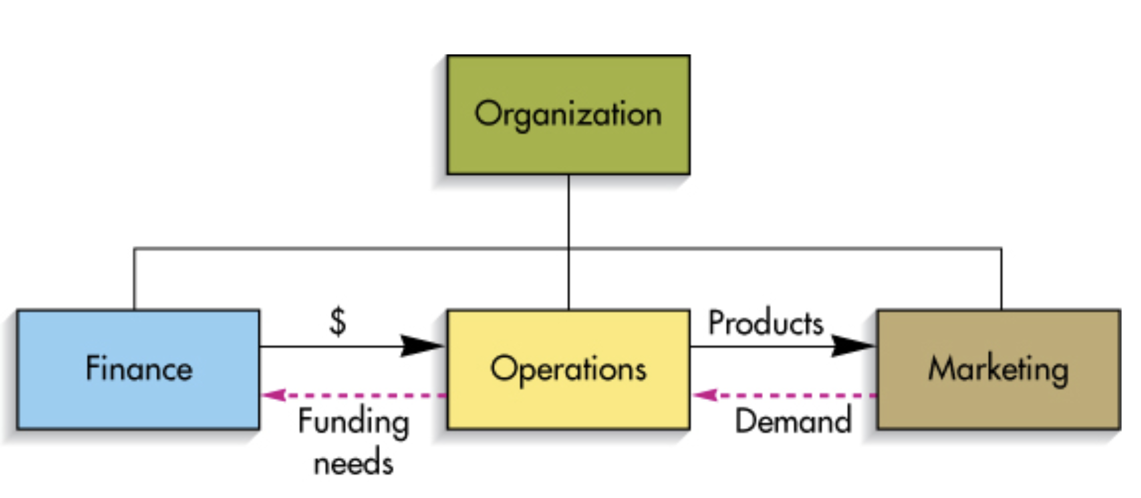

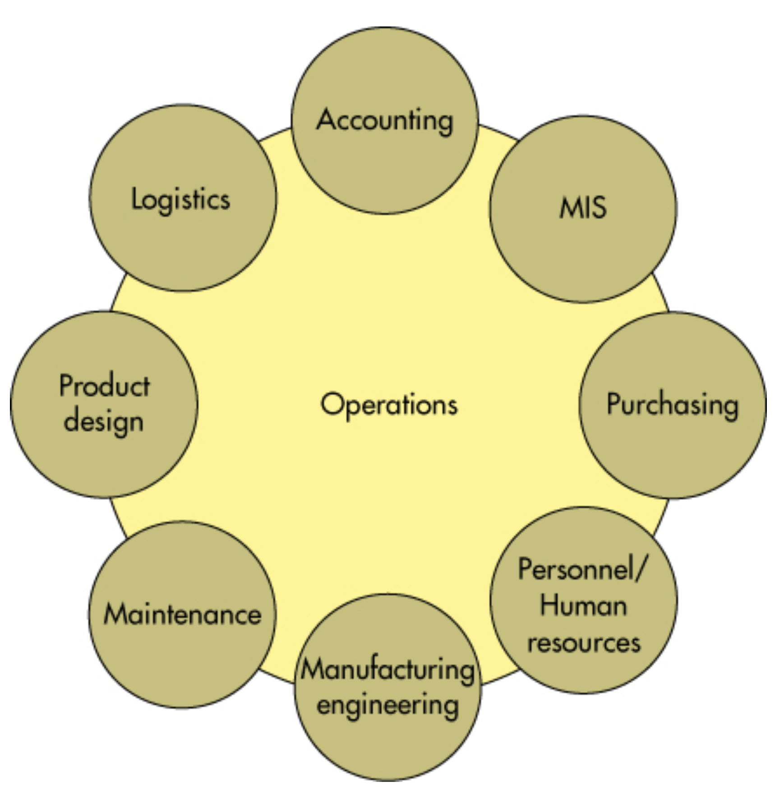

### What Operations Managers Do

**Defining the Role of the Operations Manager:**

* Core (manufacturing)
* Support (maintenance, accounting, HR, purchasing)
* Managerial (general administration)

**The Operations Manager’s Job:**

|  |  |
| --- | --- |
| **Management Process** | **Field of Responsibility** |
| Planning | Capacity, location, make or buy |
| Organizing | Centralization, specialization, staffing |
| Controlling | Inventory, quality, motivation |
| Directing | Scheduling, incentive plans, work orders |

**Establishing Priorities:**

* Pareto Phenomenon: A few factors account for a high percentage of the occurrence of some event(s)
* 80/20 Rule: 80% of problems are caused by 20% of the activities

### The Importance of Collaboration

* A clear and comprehensive systems-based approach for issues is in demand
* Coordination between marketing and operations is essential for success
* For example, changing a package form needs to account for inventory costs and order quantities, existing packaging inventories, new equipment needs, plant layout, etc.

### Concept of Value Added

* Difference between the cost of goods and the value of outputs
* For services, the cost of services and the value placed on those services by individuals
* Value of output is determined by the prices that consumers are willing to pay for goods

### Stakeholder Management

* “Any group or individual who can affect or is affected by the achievement of an organization’s objective” (Freeman, 1984)
* Stakeholders may include customers, employees, suppliers, financiers, etc.

## Demand Forecasting

* Underlies strategic planning when it comes to plant or service design
* Essential for budgeting and determining capital requirements for both inputs and projects
* Dictates medium-term operations and affects short-term operations

### Forecast Commonalities

1. Rely, to some extent, upon past demand and criteria identified as affecting that demand
2. Forecasts of aggregate demand for similar goods is more accurate than forecasts for individual items within a category
3. Increasing forecast horizons introduces greater uncertainty and reduced reliability

### Requirements for a Useful Forecast

1. Forecast should be long enough to make it relevant
2. Limitations on accuracy must be clearly stated
3. Forecasting method should be reliable
4. Operations forecasts should be expressed in units

### How it is Done

1. Determine why you are forecasting (who wants it and what will they use it for)
2. Assess and state the required levels of detail and accuracy
3. Establish a forecasting horizon
4. Gather historical data
5. Select a forecasting method
6. Complete the forecast
7. Monitor its accuracy

### Judgemental Approaches

* Includes things such as hunches, personal opinions, non-quantitative observations
* Can be tainted by personal bias
* Developed as a non-quantitative analysis of historical data or analysis of subjective data

### Quantitative Approaches

* Utilize hard data from the past (untainted from personal bias)
* Time series models (identifies patterns in data and projects these trends into the future)
* Associative models (describes demand in terms of independent causal variables)

### Time Series Modeling

* A time-ordered sequence of observations taken at regular intervals over a period of time
* Assumes that future values of the series can be estimated from past values

**Data Behaviour:**

* Average (level): Horizontal pattern
* Trend: Persistent upward or downward pattern
* Seasonality: Regular wavelike pattern that corresponds with some repeatable event
* Cycles: Lasts more than one year and looks at longer-term patterns
* Irregular Variations: One-time events that tend to skew the data
* Random Variations: Multitude of minor events that combine to affect the data

**Methods:**

Naïve Method:

* Assumes that the value of the data for the last period will be the value of the next period
* Can be applied to average, trend, and seasonal data

|  |  |  |  |
| --- | --- | --- | --- |
| **Period** | **Actual** | **Change** | **Naïve Forecast** |
| $$t-1$$ | $$50$$ |  |  |
| $$t$$ | $$53$$ | $$+3$$ |  |
| $$t+1$$ |  |  | $$53+3=56$$ |

**Averaging Methods:**

* Three types: moving average, weighted moving average, and exponential smoothing
* Requires stable data and can handle random variations but not irregular data points

Moving Average Method:

* Average of recent observations are used as the basis for the current forecast
* Choice of the number of data points used for the calculation will affect the sensitivity of the average to the most recent data point

|  |  |
| --- | --- |
| **Period** | **Demand** |
| 1 | 42 |
| 2 | 40 |
| 3 | 43 |
| 4 | 40 |
| 5 | 41 |

$$F_{6}=\frac{43+40+41}{3}=41.33$$

$$F_{7}=\frac{40+41+39}{3}=40.00$$

Weighted Moving Average Method:

* Assigns a heavier weight to more recent data points
* Sum of the weights must equal to one

$$F_{6}=0.40\left(41\right)+0.30\left(40\right)+0.20\left(43\right)+0.10\left(40\right)=41.0$$

$$F_{7}=0.40\left(39\right)+0.30\left(41\right)+0.20\left(40\right)+0.10\left(43\right)=40.2$$

Exponential Smoothing:

* Current forecast that is based upon the previous period plus a portion of the difference between the actual outcome in the period and the quantity forecast for that period
* Notation: $F_{t}=F_{t-1}+α\left(A_{t-1}-F_{t-1}\right), where 0<α<1$
* For example, if previous forecast was 42 units, previous actual demand was 40 units, and $α=0.10$, the new forecast would be:
$$F_{t}=42+0.10\left(40-42\right)=41.8$$

* Then, if the actual demand turned out to be 43, the next forecast would be:

$$F_{t+1}=41.8+0.10\left(43-41.8\right)=41.92$$

**Associative Forecasting:**

* If I want to predict ridership from a new train station, what data might I look at?

1. Find (predictor) variables associated with ridership at other stations
$Associated=correlated=as one moves the other moves$

2. Create a model that shows the relationship between the predictor variables and the predicted variable (ex. ridership)
3. Technique is regression analysis (ex. Simple linear regression with one variable, multiple regression that can be non-linear)
4. Test the model to see which variables are most useful in predicting ridership ($r^{2}$)
5. Use the model to predict ridership, given the values of the predictor variables

**Associative Models:**

* Predictor Variables ($x$): Used to predict values of the variable of interest ($y$) – independent variables
* Linear Regression: Process of finding a straight line that best fits a set of points on a graph – least squares estimation
* Multiple Regression: Models with more than one predictor variables – computations complex, created with computer

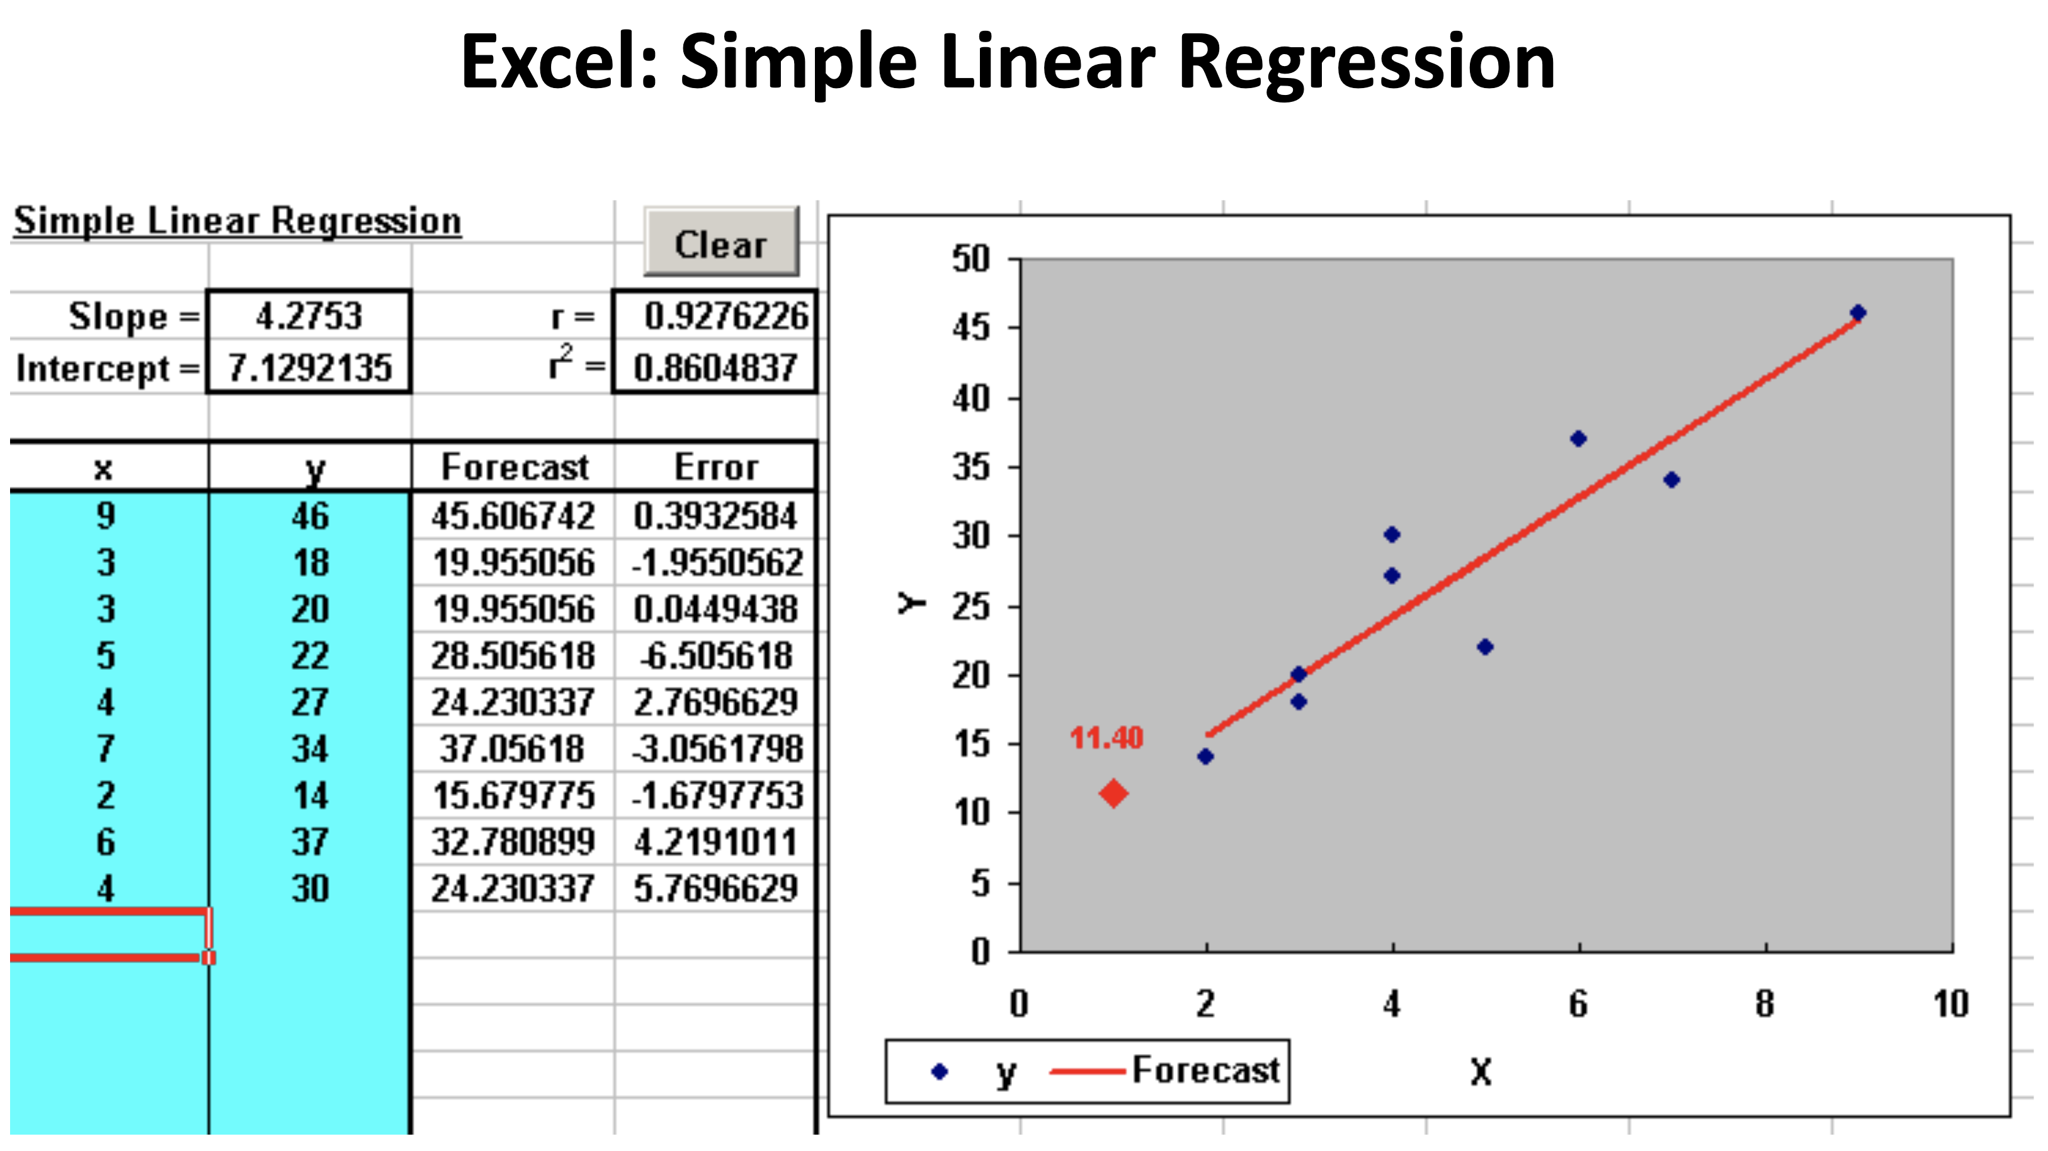

**Correlation and Excel:**

* Correlation Coefficient ($r$): Measure of strength of the relationship between two variables
  + Ranges from $-1$ (moves in same direction) to $+1$ (moves in opposite direction)
* $r^{2}$ measures proportion of variation in the values of $y$ that is “explained” by the predictor variables in the regression model
  + Ranges from $0$ to $1$ (higher values means more useful predictors)

**Linear Regression Assumptions:**

* Predictions are being made only within the range of observed values
* Variations around the line are random and normally distributed

### Forecasting Accuracy

* Definition: A judgement or measurement of how accurate the forecast is to actual results from the demand being forecast (or predicted)
* Presence of random variables such as changes in tastes, preferences, and values of consumers make it almost impossible to create a perfect prediction of future demand

**Forecasting Error:**

$$E_{t}=A_{t}-F_{t}$$

* In words: The error $E$ for period $t$ is simply the difference between the actual demand $A$ and the forecast demand $F$ for the same period
* **Bias:** Sum of forecast errors, if positive then forecasts are underestimating demand, if negative then forecasts are overestimating demand

**Three Methods for Measuring Accuracy:**

1. **Mean Absolute Deviation: $MAD=\frac{∑\left|e\right|}{n}$**
2. **Mean Squared Error: $MSE=\frac{∑{\left(A_{i}-F_{i}\right)}^{2}}{n}$**
3. **Mean Absolute Percent Error: $MAPE=\frac{∑[\frac{\left|A_{i}-F_{i}\right|}{A_{i}}×100]}{n}$**
   * $e$ is the value of individual forecast errors, $n$ is the number of observations

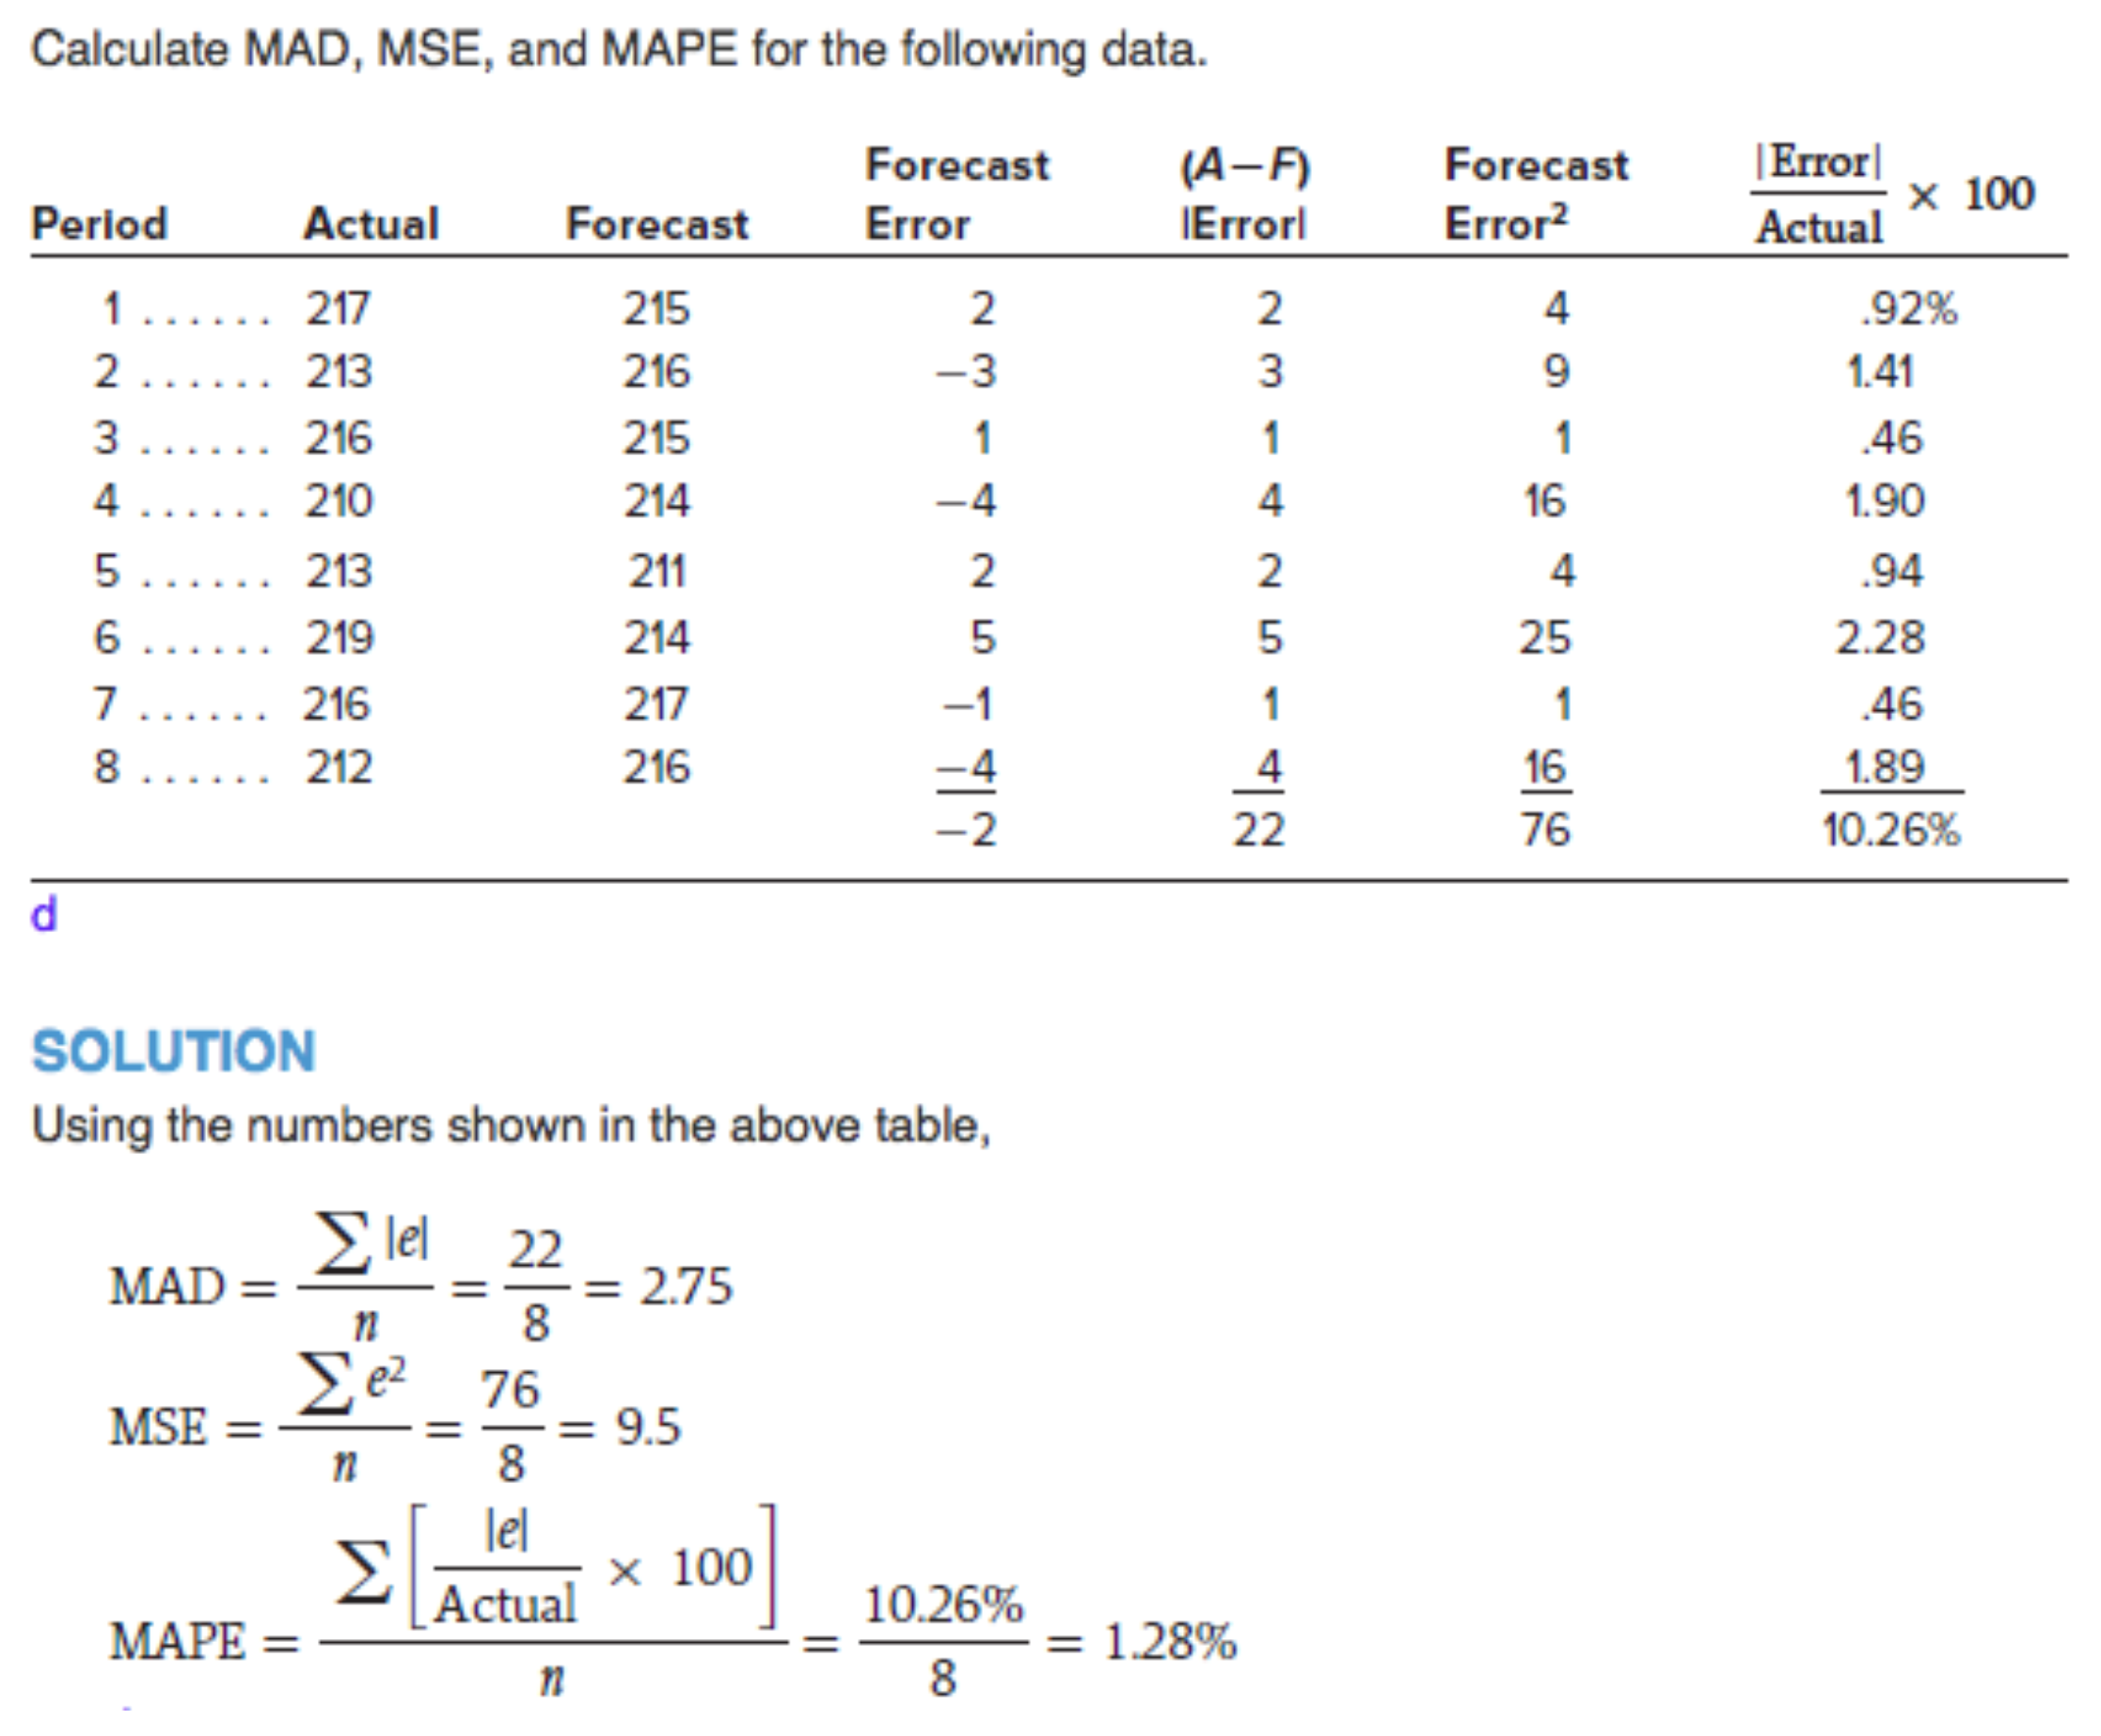

### Dealing with Control Charts

* + Objective: Measure the accuracy of the forecasts within a set of prescribed boundaries
  + Control limits “ $s$” based upon the square root of the mean squared error: $s=√MSE$

**Solution Process:**

1. Setup the required data table and make the necessary calculations
2. Check average forecast error and comment on its proximity to zero
3. Calculate the square root of the forecast errors
4. Determine the 2s control limits
5. Compare forecast errors to the control limits

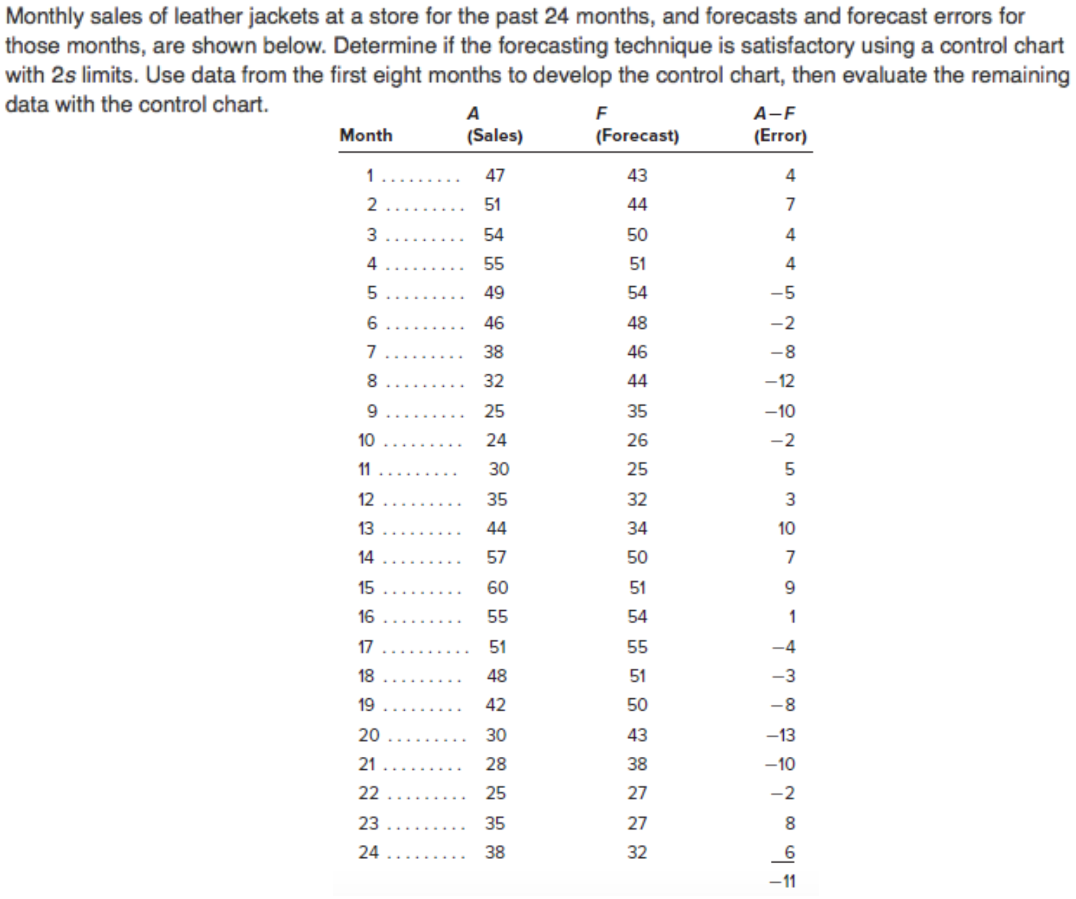

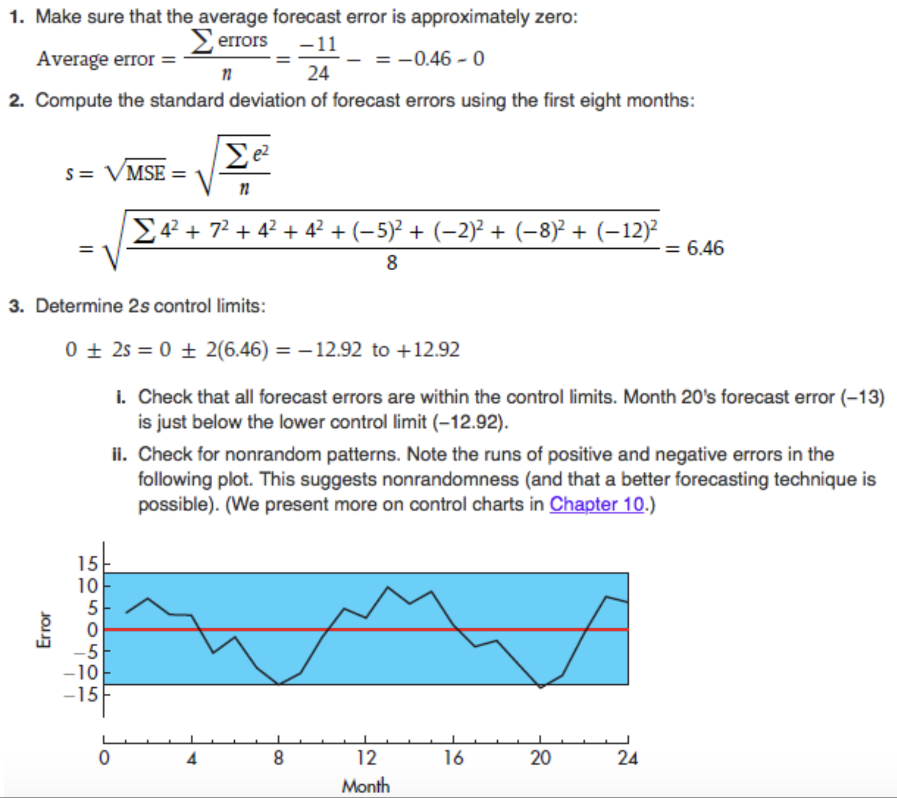

# Demand Forecasting (II) and Product Design

## Demand Forecasting

### Trend Adjusted Forecasts (TAF)

* Slightly more complicated version of exponential smoothing:
$$S_{t}=TAF_{t}+α\left(A_{t}-TAF_{t}\right)$$

$$T_{t}=T_{t-1}+β(S_{t}-S_{t-1}-T_{t-1})$$

$$TAF_{t+1}=S_{t}+T_{t}$$

* $S_{t}$: Smoothed series at the end of period $t$
* $T_{t}$: Smoothed trend at the end of period $t$
* $α$ and $β$ are arbitrary smoothing constants
* $A_{t}$ is the actual data from period $t$

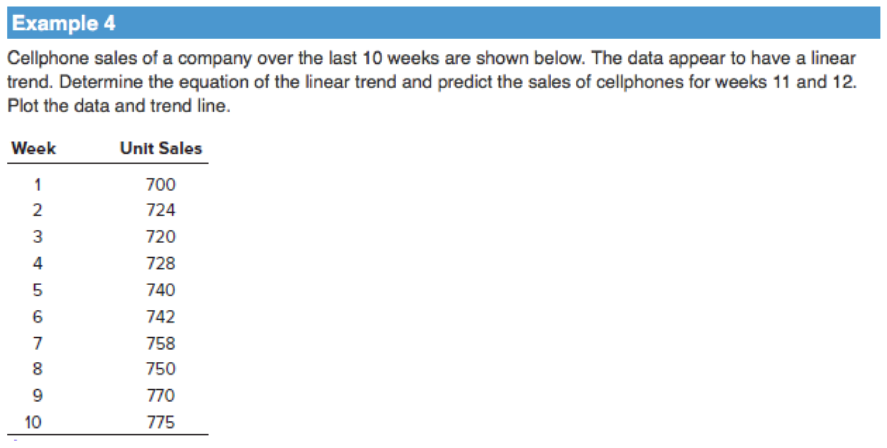

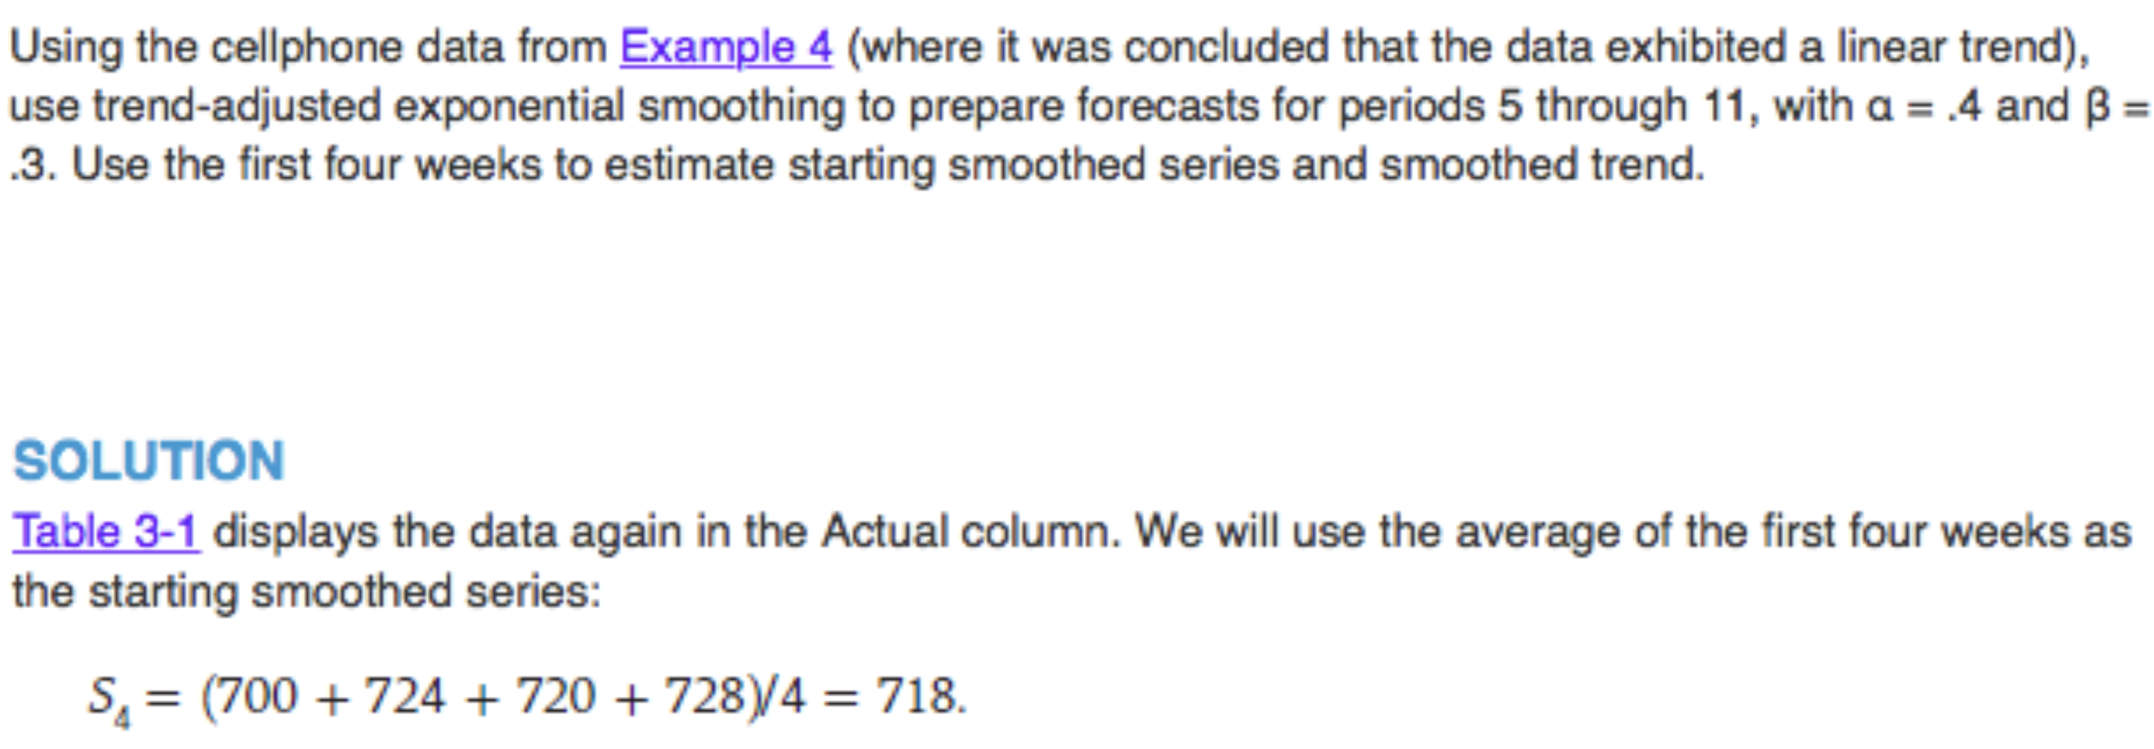

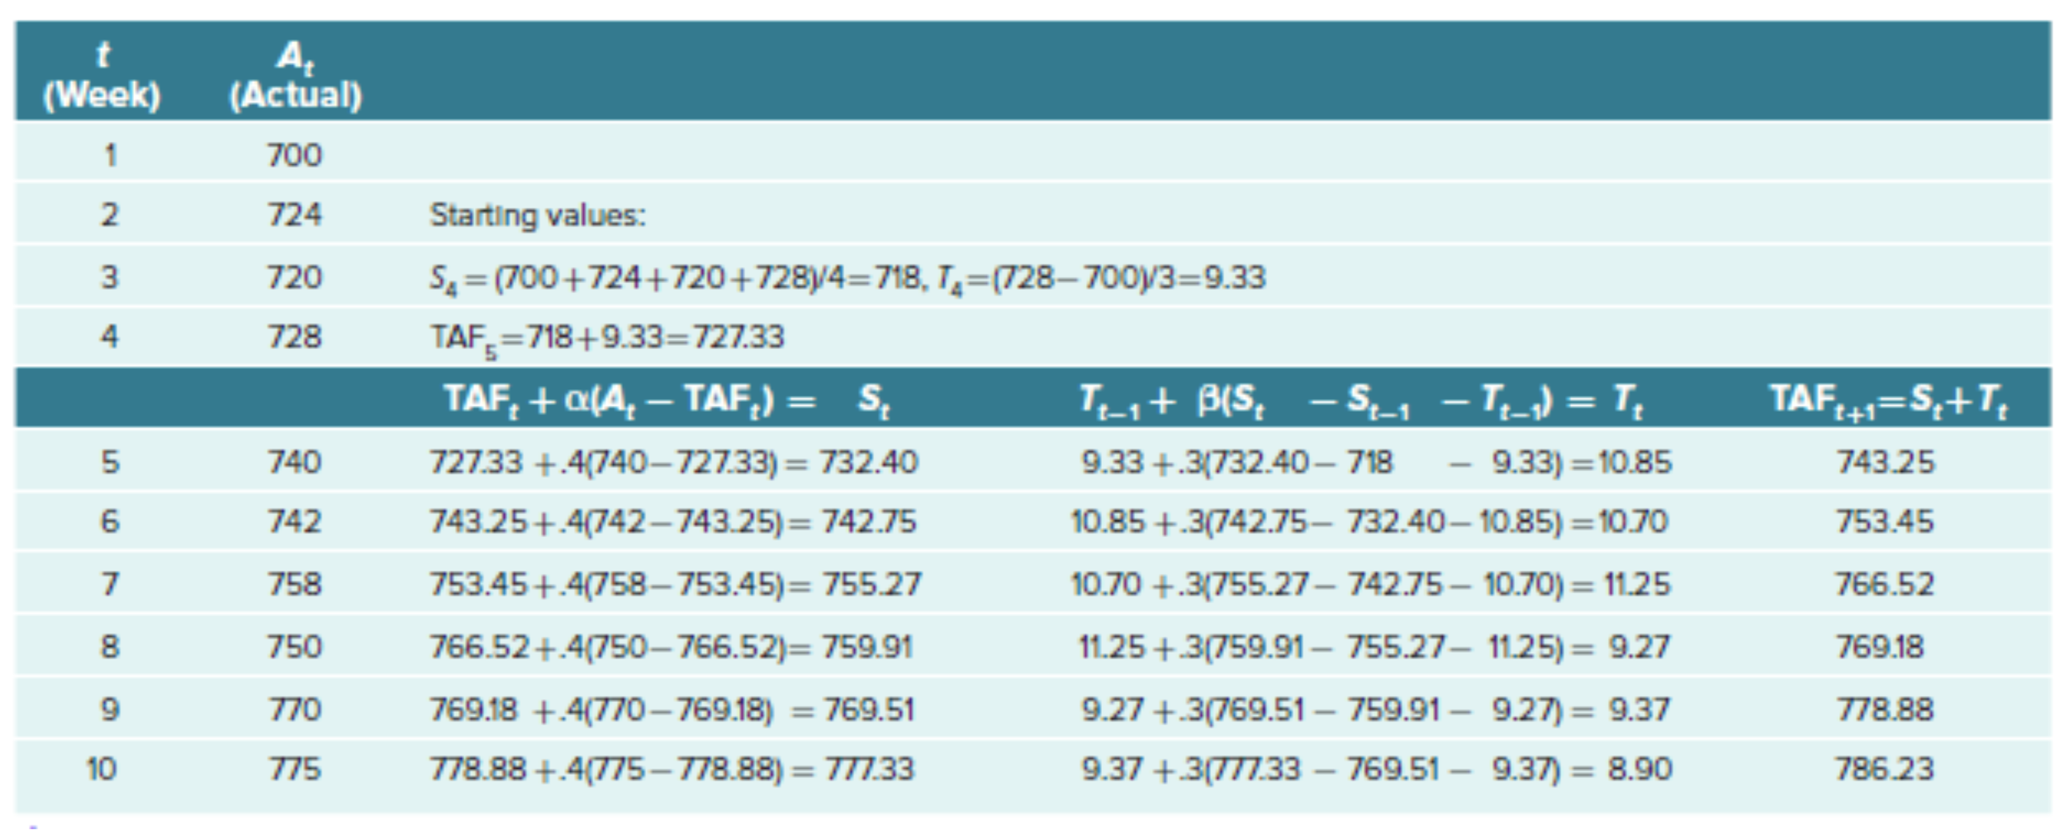

### Review of Seasonality

* Seasonal data is defined as data that exhibits a repeating pattern that is tied to some regularly occurring event (summer ice cream sales, winter natural gas sales, etc.)
* Expressed as the amount of deviation from the period average, by using the average over the length of the repeating pattern to calculate an adjustment factor
* Seasonality is measured relative to the trend

**Computing Seasonal Relatives:**

* Need to identify the trend in the data in order to compare seasonal values to some average
* Decompose data into smaller segments through use of a centered moving average (CMA)
* Number of periods in CMA is equal to the number of “seasons” portrayed in the data
* Example: Quarterly data, use a 4-period CMA

|  |  |  |  |
| --- | --- | --- | --- |
| **Period** | **Historical Value** | **CMA** | **Seasonal Relative** |
| $$1$$ | $$79$$ |  | $$79/76.67=1.03$$ |
| $$2$$ | $$86$$ | $$76.67$$ | $$86/76.67=1.12$$ |
| $$3$$ | $$65$$ |  | $$65/76.67=0.85$$ |

**Steps in Dealing with Seasonal Data:**

1. Write out the given data in table form
2. Calculate the appropriate Centered Moving Average (CMA)
3. Use CMA to calculate seasonal relatives
4. Average and adjust the seasonal relatives to the relevant seasonal data
5. Use the “adjusted” averaged seasonal relatives to de-seasonalize the original data
6. Describe the data (does it exhibits a linear trend, upward or downward)
7. Using calculated (GIVEN) Linear Trend Equation, calculate the forecasts for the periods
8. Re-seasonalize forecast using the average seasonal relatives calculated in Step 4

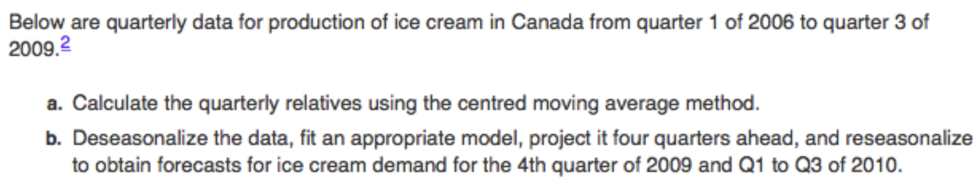

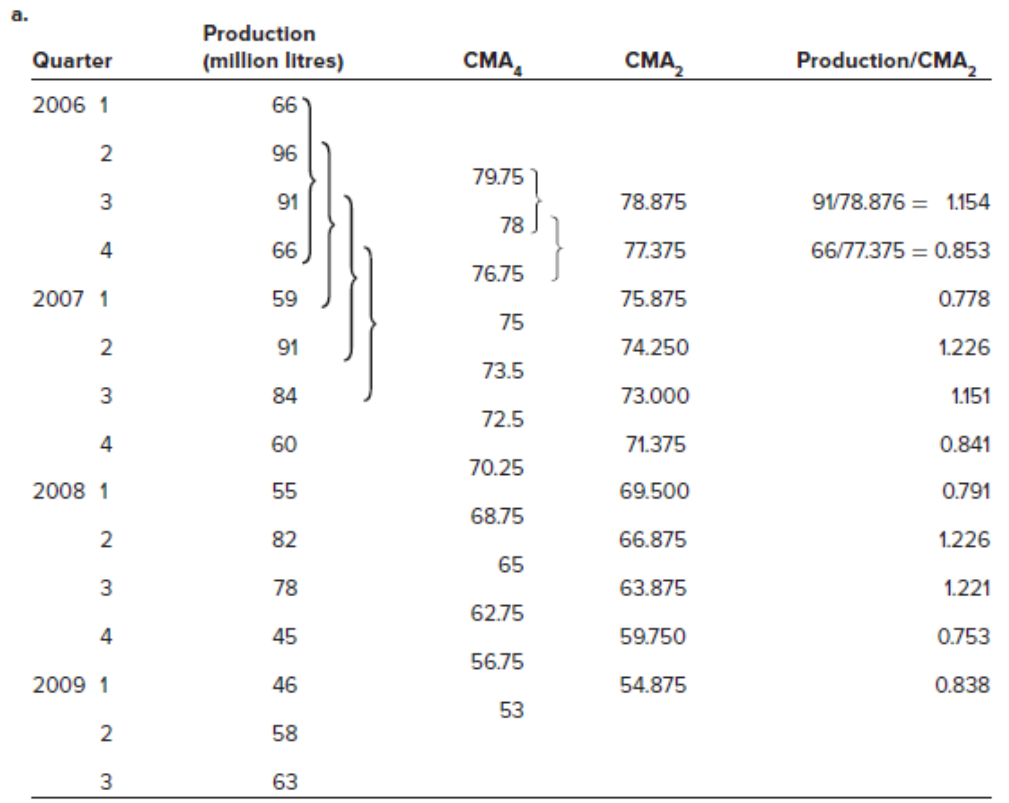

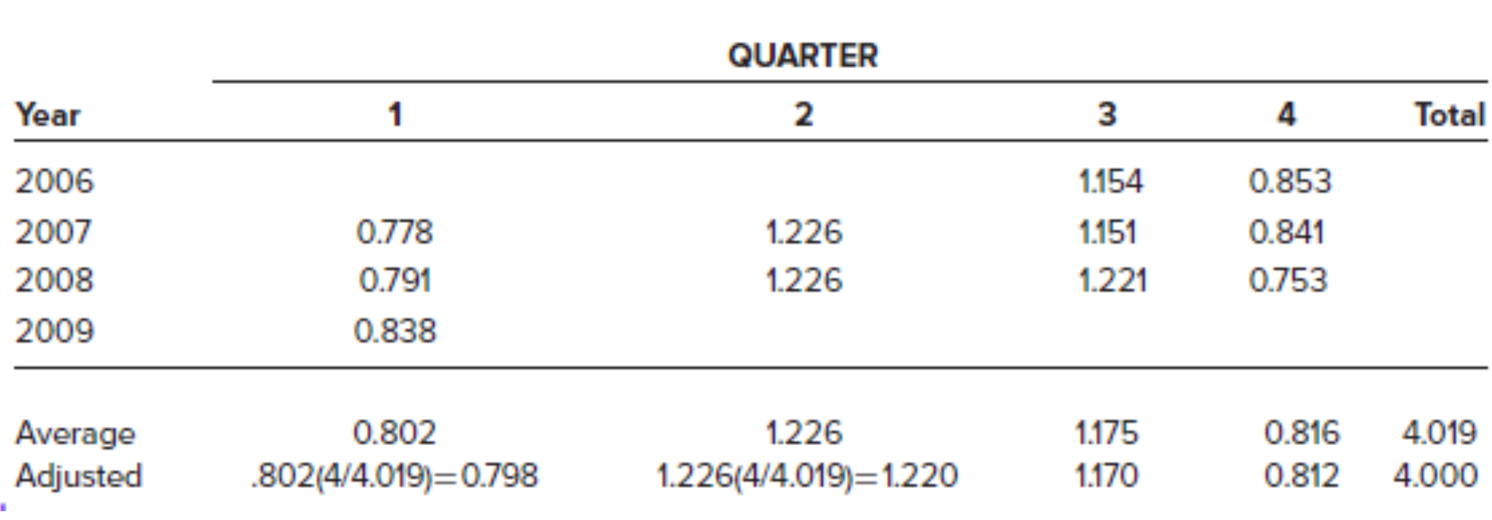

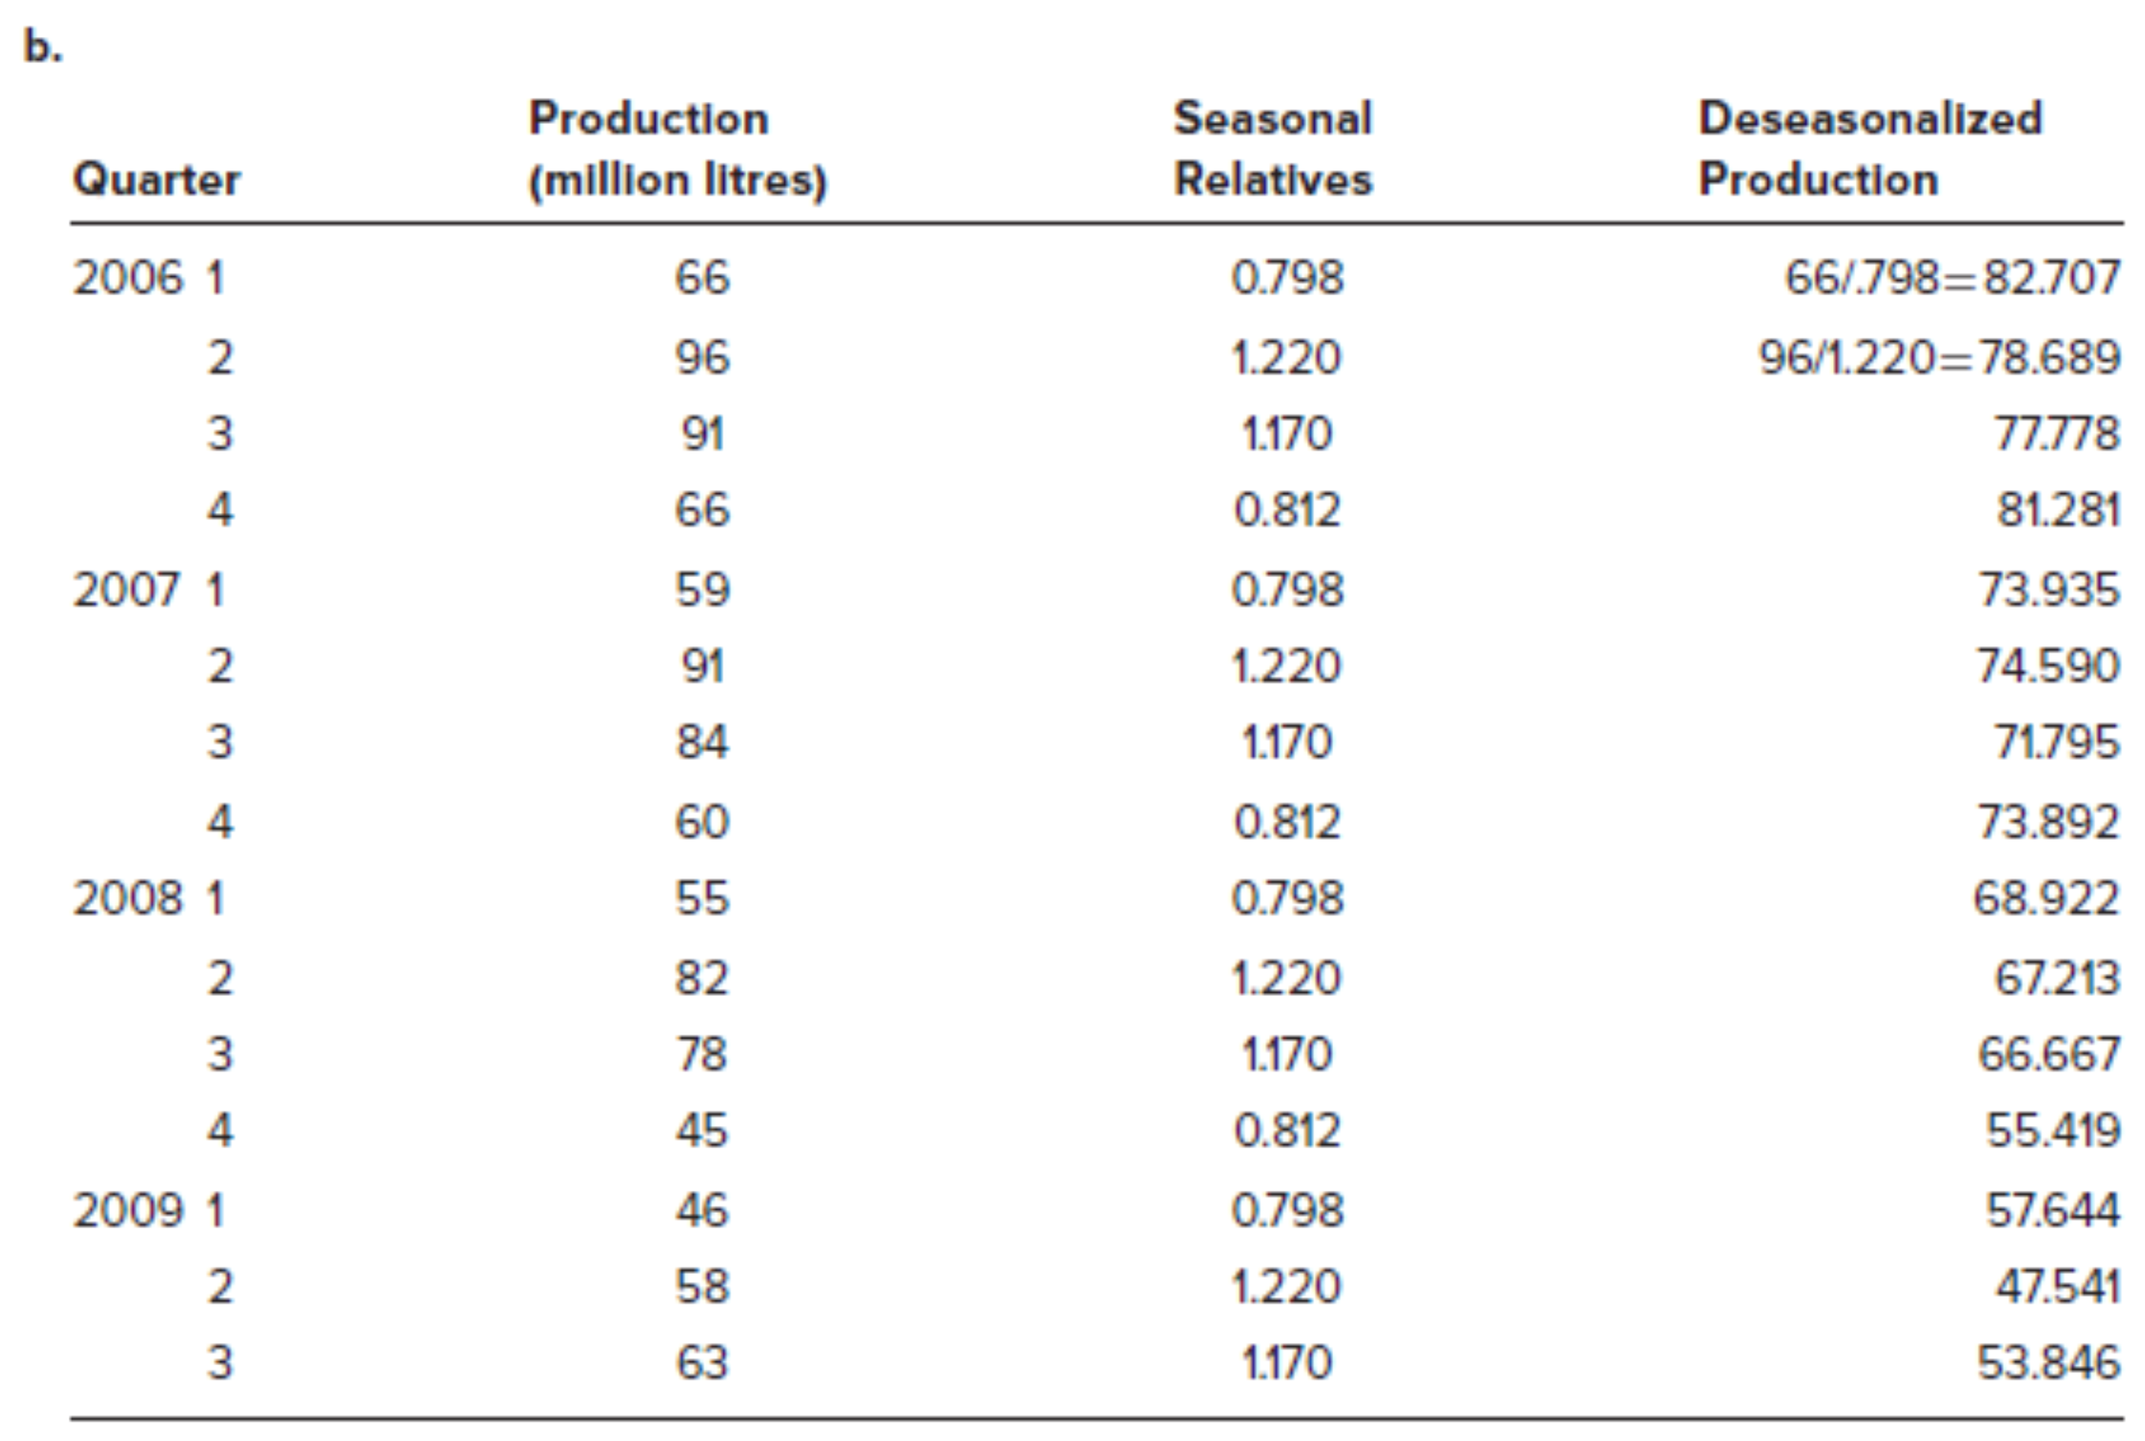

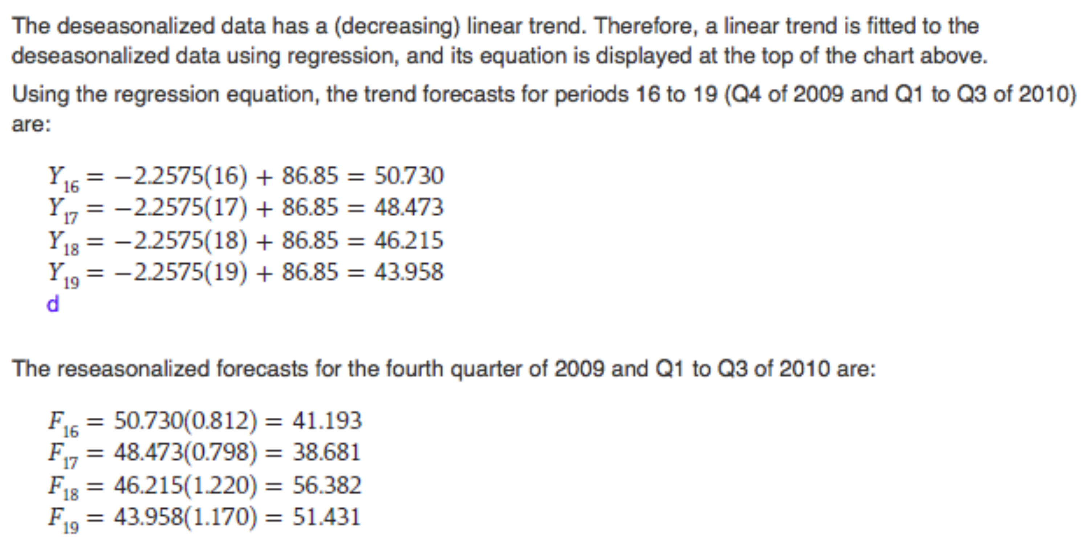

## Product Design

Product Design:

* Determines the form and function
* Is expensive and time consuming
* Governs the level of product quality and hence the level of customer satisfaction
* Contributes to competitive advantage

### Product Design Process

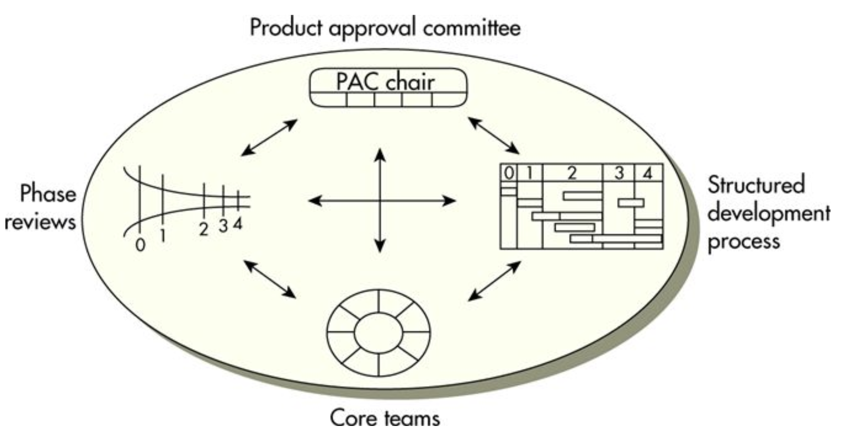

* Product Approval Committee: Management team
* Core Teams: Members from all aspects of the organization
* Phase Reviews: Milestones
* Structural Development: Structured and explicit project management technique

### Sequential Steps in New Product Developments

* + - 1. Idea Generation
      2. Build a Business Case: Market and Competitive Analysis
      3. Development: Product attributes we need to meet or exceed customer expectations?
      4. Testing and Validation
      5. Launch

### Sources of New Product Ideas

* + Customers, front-line production workers, suppliers, competitive products, R&D

### Key Issues in Product Design

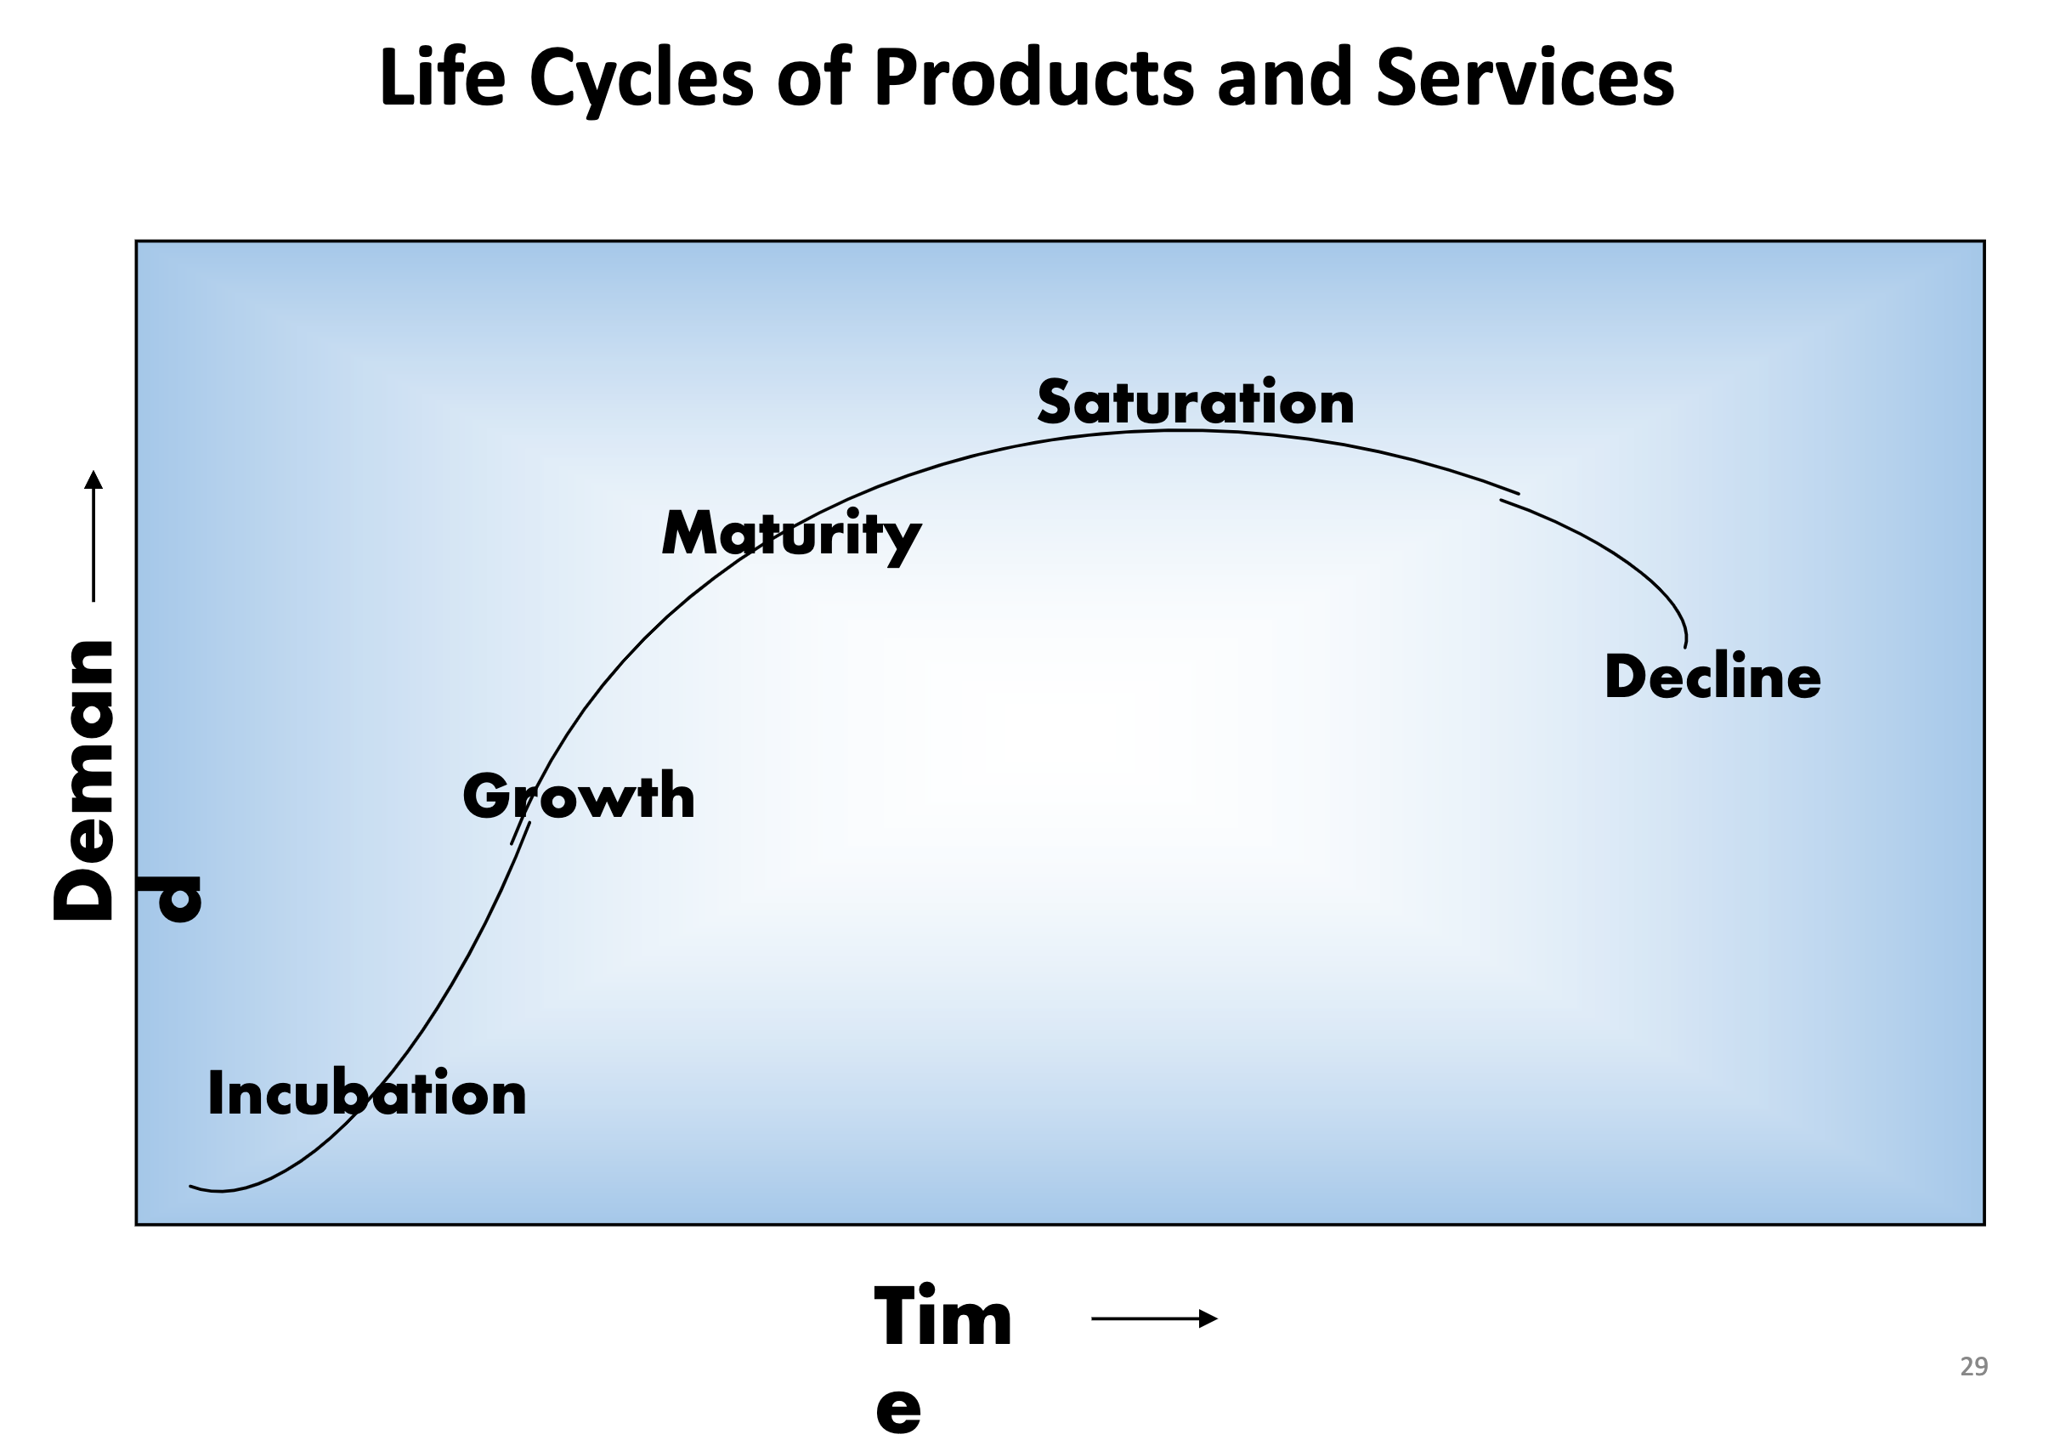

**Standardization**

* + Every consumer receives the same product
  + High volumes of the same product reduce costs through economies of scale
  + Can reduce the level of variety in product offerings
  + May breed a climate of resistance of product improvements and modifications

**Design for Mass Customization:** Attempts to reach a compromise between the benefits of standardization for the producer and the desire of consumers for variety and customization

**Reliability:** Ability of a product (or part) to perform for its intended use under normal conditions

**Robust Design:** Products that can stand up under a wide range of operational environments

**Legal and Ethical Issues:** Product liability (injuries), ethical issues (sub-standard products)

**Design for the Environment:** Energy efficient, minimization of waste/packaging, etc.

**Concurrent Engineering:** Bringing design engineering staff into direct work with others

**Computer Assisted Design (CAD):** Computerizes design to avoid hand-drawn designs

**Design for Manufacturing and Assembly:** Ease can be incorporated into the design

**Component Commonality:** Occurs when a component can be used in multiple products

# Capacity Planning and Process Design/Facility Layout

## Strategic Capacity Planning

### Overview

* + **Capacity:** Upper workload limit that a production unit can accommodate
  + **Production Rate:** Measured in terms of the units of production per unit of time
  + **Capacity Time Frames:** Long-term (1-5 years), medium-term (next 12 months), short-term (up to 12 weeks)
  + **Strategic Capacity Planning:** Systematic determination of facility and equipment needs

**Importance of Long-Term Capacity**

* + - 1. Capacity directly impacts the ability of the company to meet future demand
      2. Effective capacity planning optimizes operating costs
      3. Capacity decisions have a direct impact on initial capital costs
      4. Capacity involves long-term commitment of resources
      5. Capacity can directly affect competitiveness

**Measuring Capacity**

* + Design Capacity: Max amount of output that can be produced under ideal conditions
  + Effective Capacity: Amount of output that can realistically be made given delays, etc.
    - 1. Efficiency: Ratio of actual output to effective capacity:
 $$Efficiency=\frac{Actual Output}{Effective Capacity}$$

     2. Utilization: Ratio of actual output to design capacity:

$$Utilization=\frac{Actual Output \left(or Uptime\right)}{Design Capacity \left(or Available Time\right)}$$

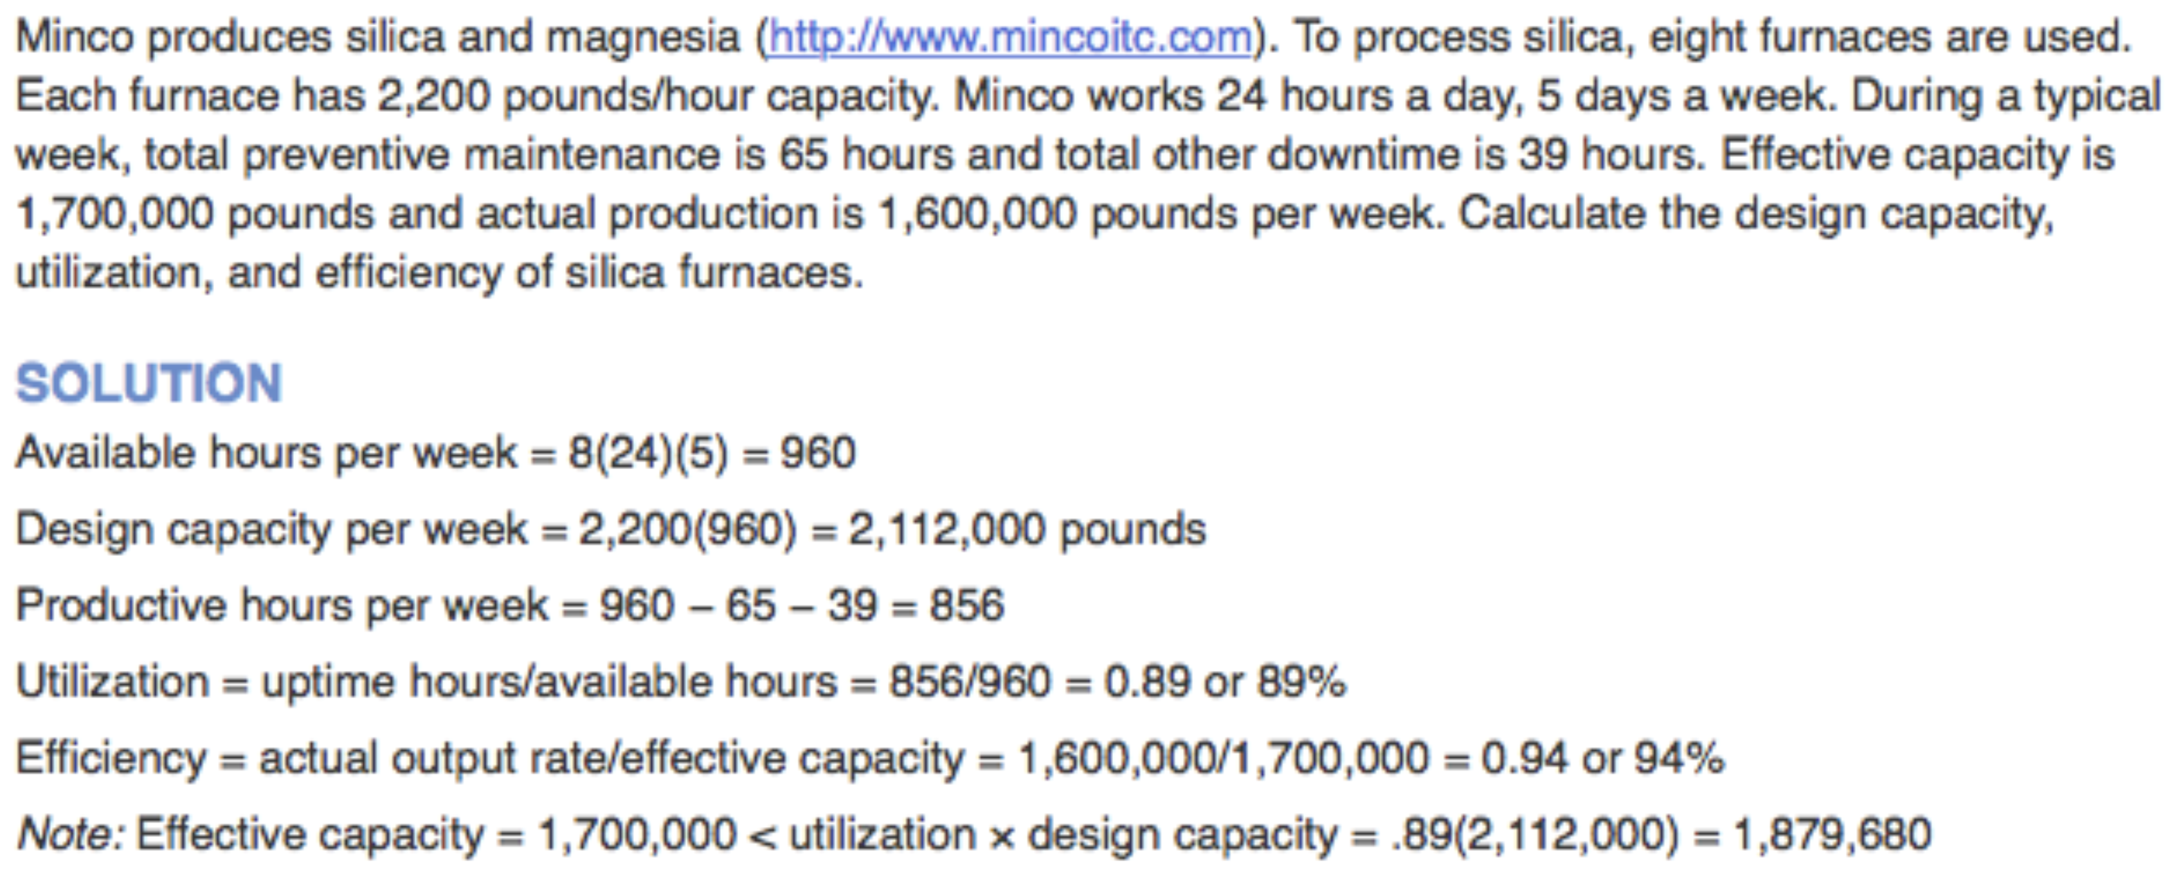

**Factors Influencing Capacity**

Facilities and equipment, products, workers, planning and operations, external factors

### Effective Capacity Planning

1. Forecast demand for a period of $5$ years or more
2. Calculate the capacity required to meet that demand
3. Measure existing in-house capacity and if necessary, begin discussing how additional capacity can be achieved

### Focusing on Long-Term Demand

1. Identify the trend as expressed over time (growth, decline, cyclical, stable)
2. Consider forecasting technique (regression, judgemental)

### Basic Capacity Requirement Question

1. Have a reasonably accurate forecast of annual demand
2. Know standard run times for each product on its respective machine
3. Know the number of hours worked per day
4. Know the number of workdays per year

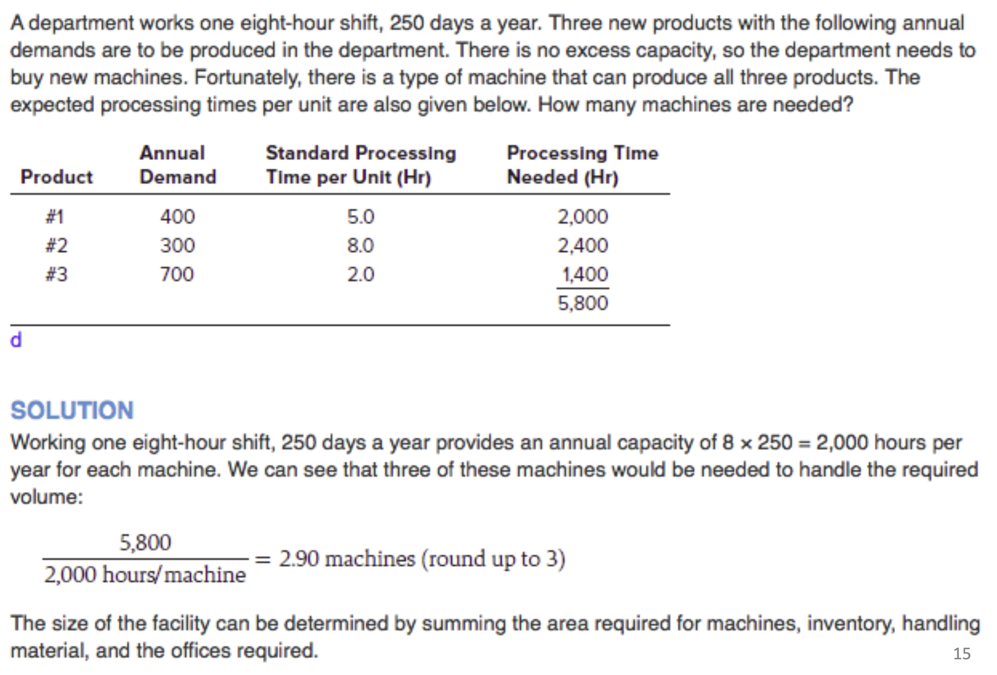

### Major Concerns When Assessing Various Capacity Alternatives

* + Design flexibility into system
  + Differentiate between new and mature products
  + Look at the organization in its entirety
  + Prepare to deal with large (chunkier) increases in capacity
  + Attempt to smooth out capacity requirements as dictated by consumer demand
  + Use of capacity cushions
  + Identify the optimal operating level

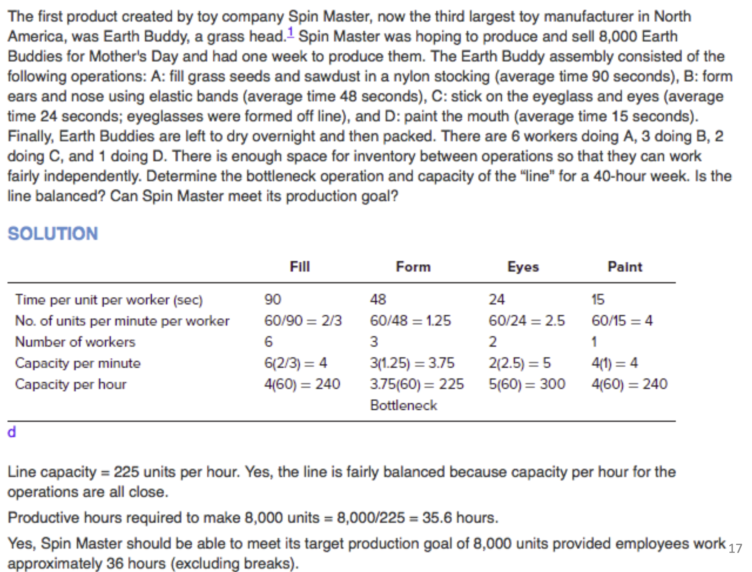

### Relationship Between Total Costs and Total Revenues

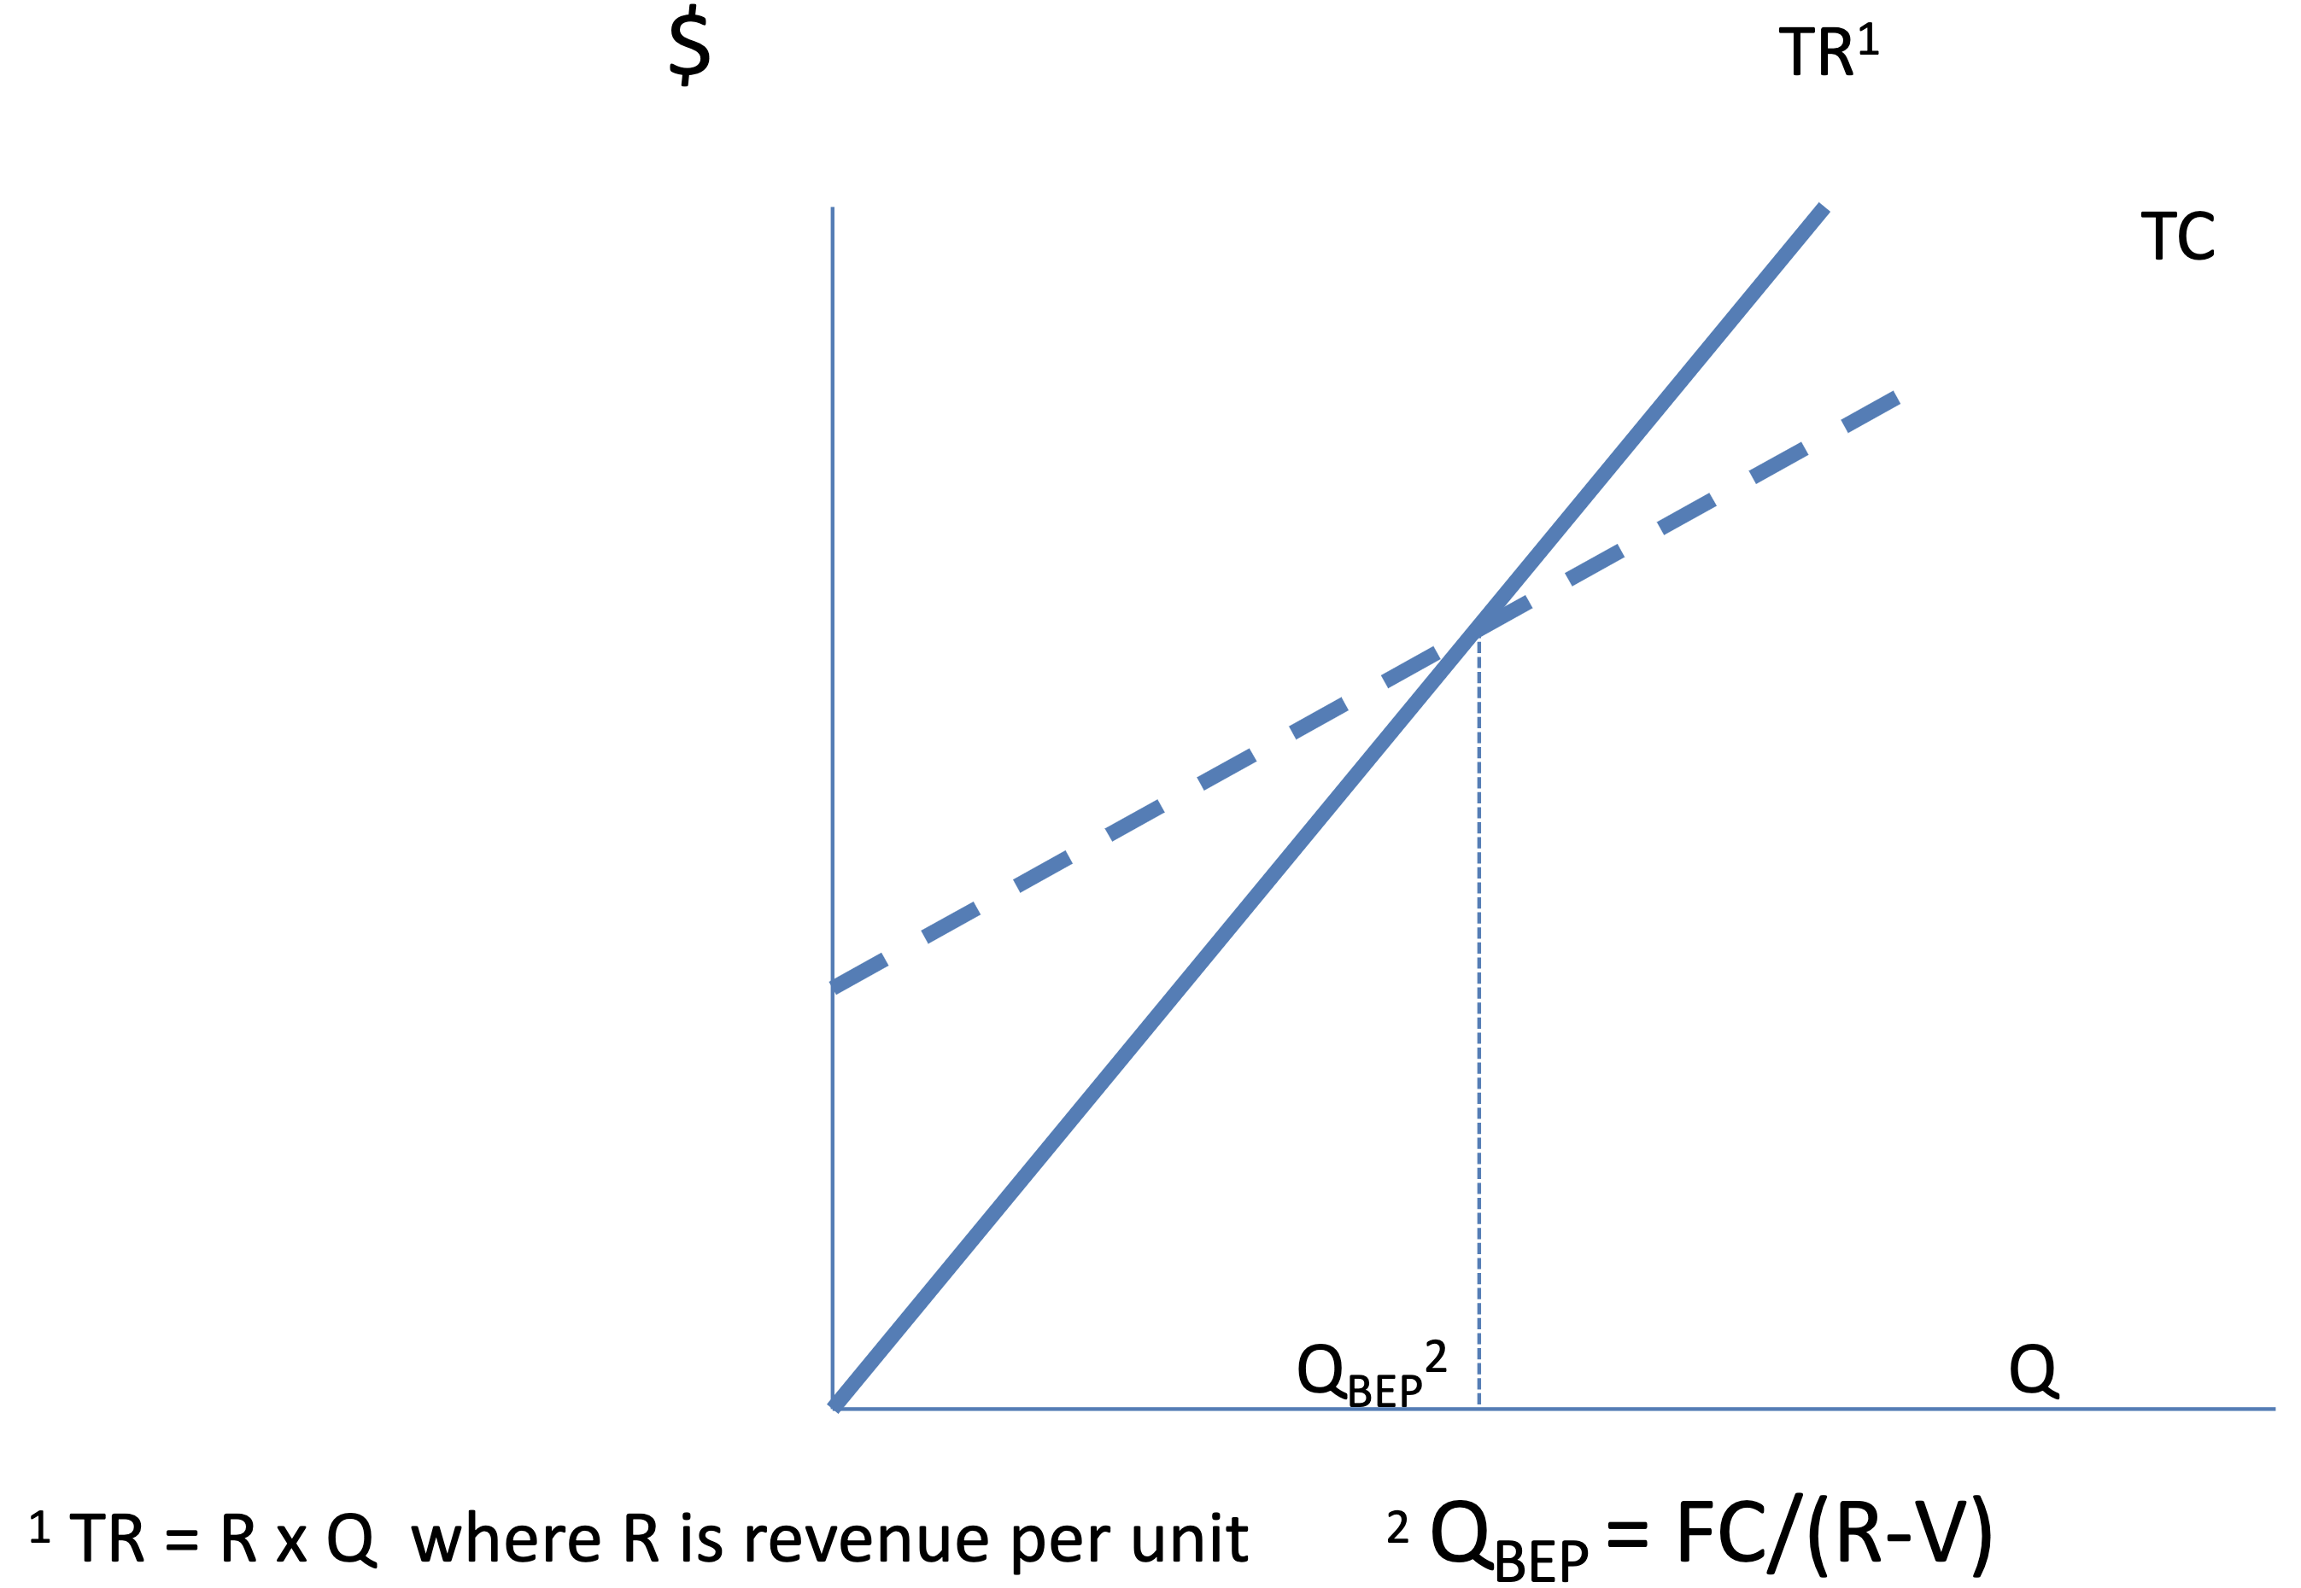

### Break-Even Analysis

* + Focuses on the relationship between costs, revenues, and volumes
  + Goal is to determine the quantity at which the alternative capacity arrangement being considered will provide an economic advantage profit

**Costs**

* + Fixed Costs ($FC$) are independent of volume produced
  + Variable Costs ($VC$) are entirely dependent upon how much is produced
  + Assume that variable costs ($v$) remains constant per unit of output ($Q$) regardless of the volume produced

$$Total Cost \left(TC\right)=FC+VC \\ Variable Costs \left(VC\right)=Q⋅v \\ Total Revenue \left(TR\right)=Q⋅R \\ Profit \left(P\right)=TR-TC=\left(Q⋅R\right)-\left(FC+VC\right)=\left(Q⋅R\right)-FC-Q⋅v \\ P=Q\left(R-v\right)-FC \\ Q=\frac{P+FC}{R-v}⇒Q_{BEP}=\frac{FC}{R-v}$$

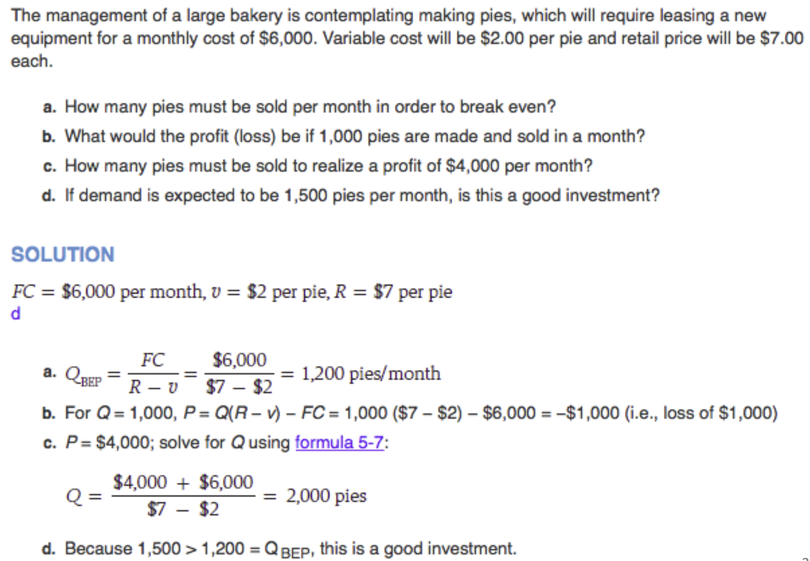

## Process Design and Facility Layout

### General Overview

**Process Design** and **Plant Layout** have long-term consequences for a company affecting:

* + Long-term feasibility of the company
  + Ability of the firm to meet its mission statement
  + Morale of the workforce who actually operate the equipment and effectively run the plant
  + The ability of the firm to meet its long-term strategic goals

### Process Types

**Job Shop**

* + Low volume of highly variable customized goods or services
  + Process is intermittent
  + Employs skilled workers
  + Uses highly flexible equipment that can be used on a wide variety of applications

**Batch Processing**

* + This describes a firm that produces a moderate quantity of a good or service
  + Process is intermittent (i.e., by batch scheduled)
  + Equipment is not as flexible as it is in a job shop
  + Workers are skilled but not as skilled as those in a job shop

**Repetitive Process**

* + Marked by higher volumes of more standardized goods
  + Lower skilled workforce – this is changing
  + Equipment is not very flexible

**Continuous**

* + High volumes of highly standardized output
  + Production is continuous and there is not typically counted
  + Low skilled workforce

### Process Considerations – Matching Process to Product Type and Volume

* + **Focused Factory Concept:** High volume shops that specialize in a particular output
  + **Hybridization:** Some organizations have been able to combine volume and specialization in their product offerings

### Automation

* + Using machinery with sensing and control devices that enable it to operate automatically
  + Advantages: Low variability, contrasts to labour, strategy necessary for competitiveness
  + Disadvantages: Costly, inflexible, can adversely affect worker morale
  + Types: Fixed automation, programmable automation, flexible automation

### Process Design

* + Determines the form and function of how the production of goods and services take place
  + Involves the allocation of resources, the sequencing of activities and control mechanisms

**Process:** Determine state of inputs, outline objectives (speed, type, cost, quality, dates, etc.)

**Conceptualize: $inputs→outputs$** , assess alternatives, incremental/hierarchical, flow diagram

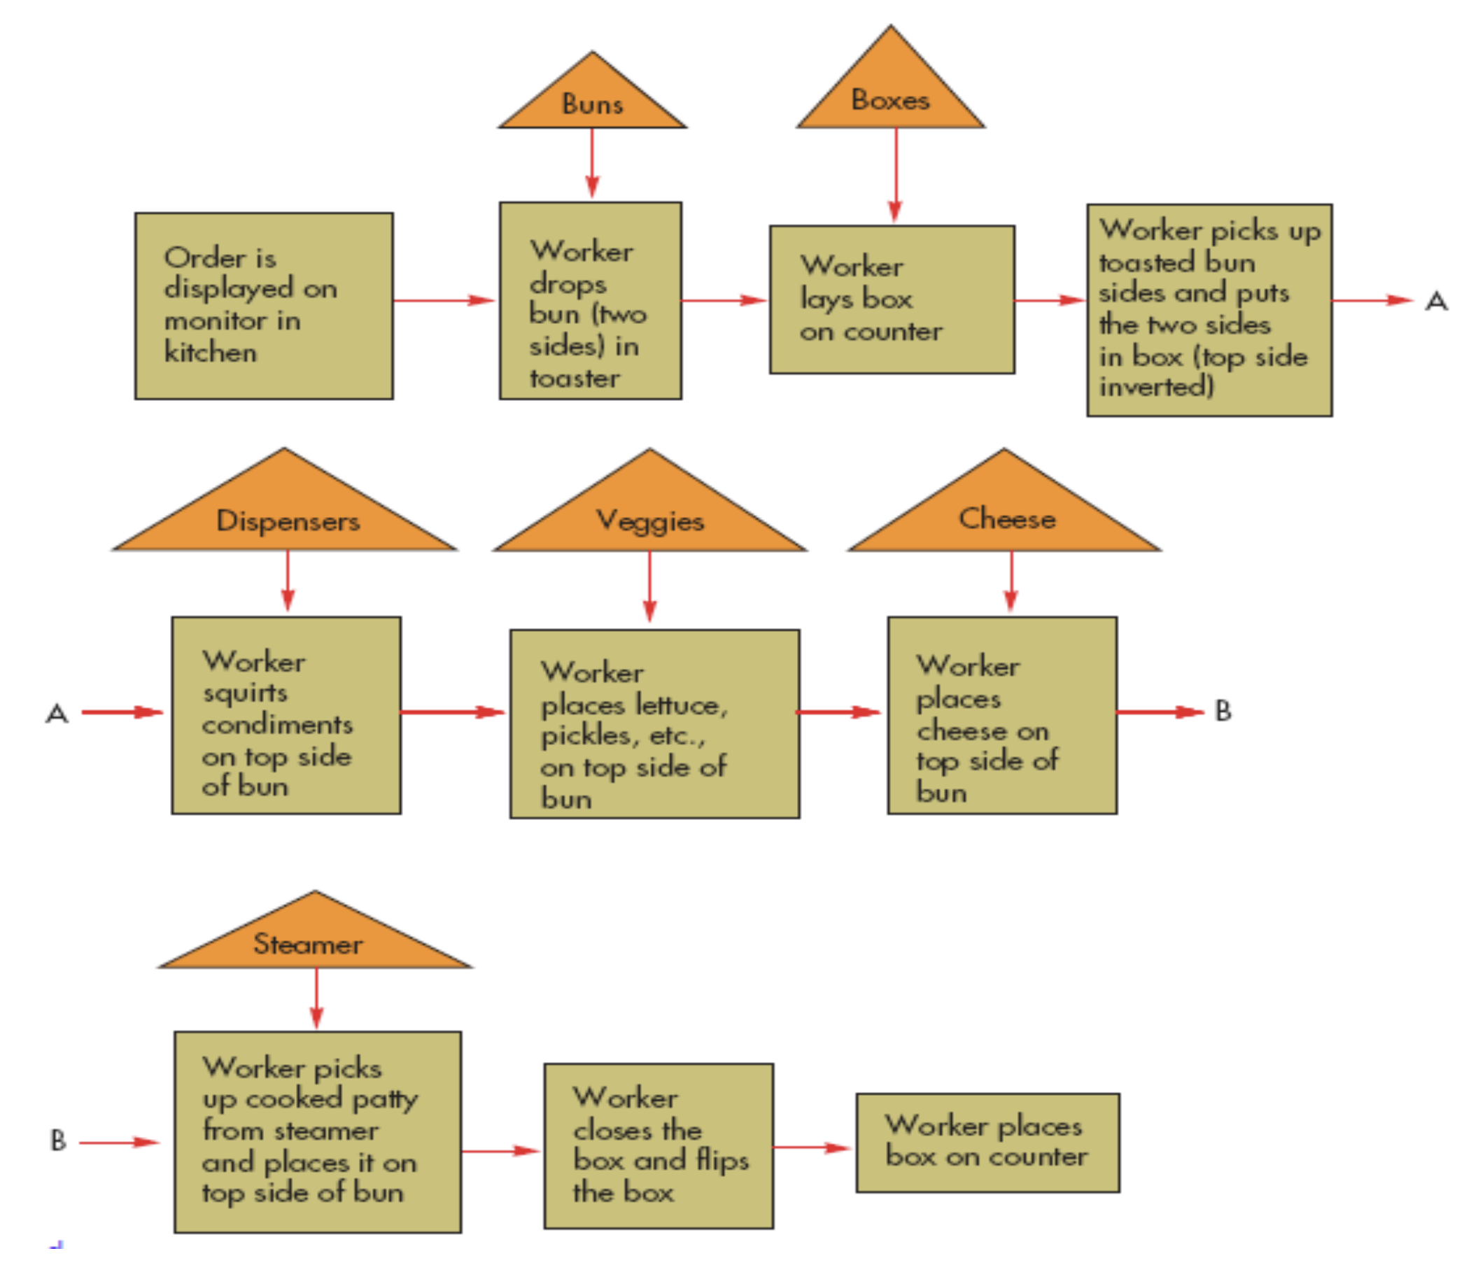

**Select:** Establish design of choice, build a prototype (computer model) of the process and test it

**Create:** Specify machinery, determine labour requirements, design placement and work centers

**Implement:** Buy equipment, hire and train workers, initiate trial runs

### Fail-Safe Service Process

* + Customer presence infers that quality and delivery problems are going to have immediate consequences
  + This suggests that the service provider has a great incentive to ensure that the process is fail-safe, i.e., not prone to failure or on the positive side, to manage process design

### Service Process Design

Service process design involves the direct or indirect involvement of the customer or of something belonging to the customer.

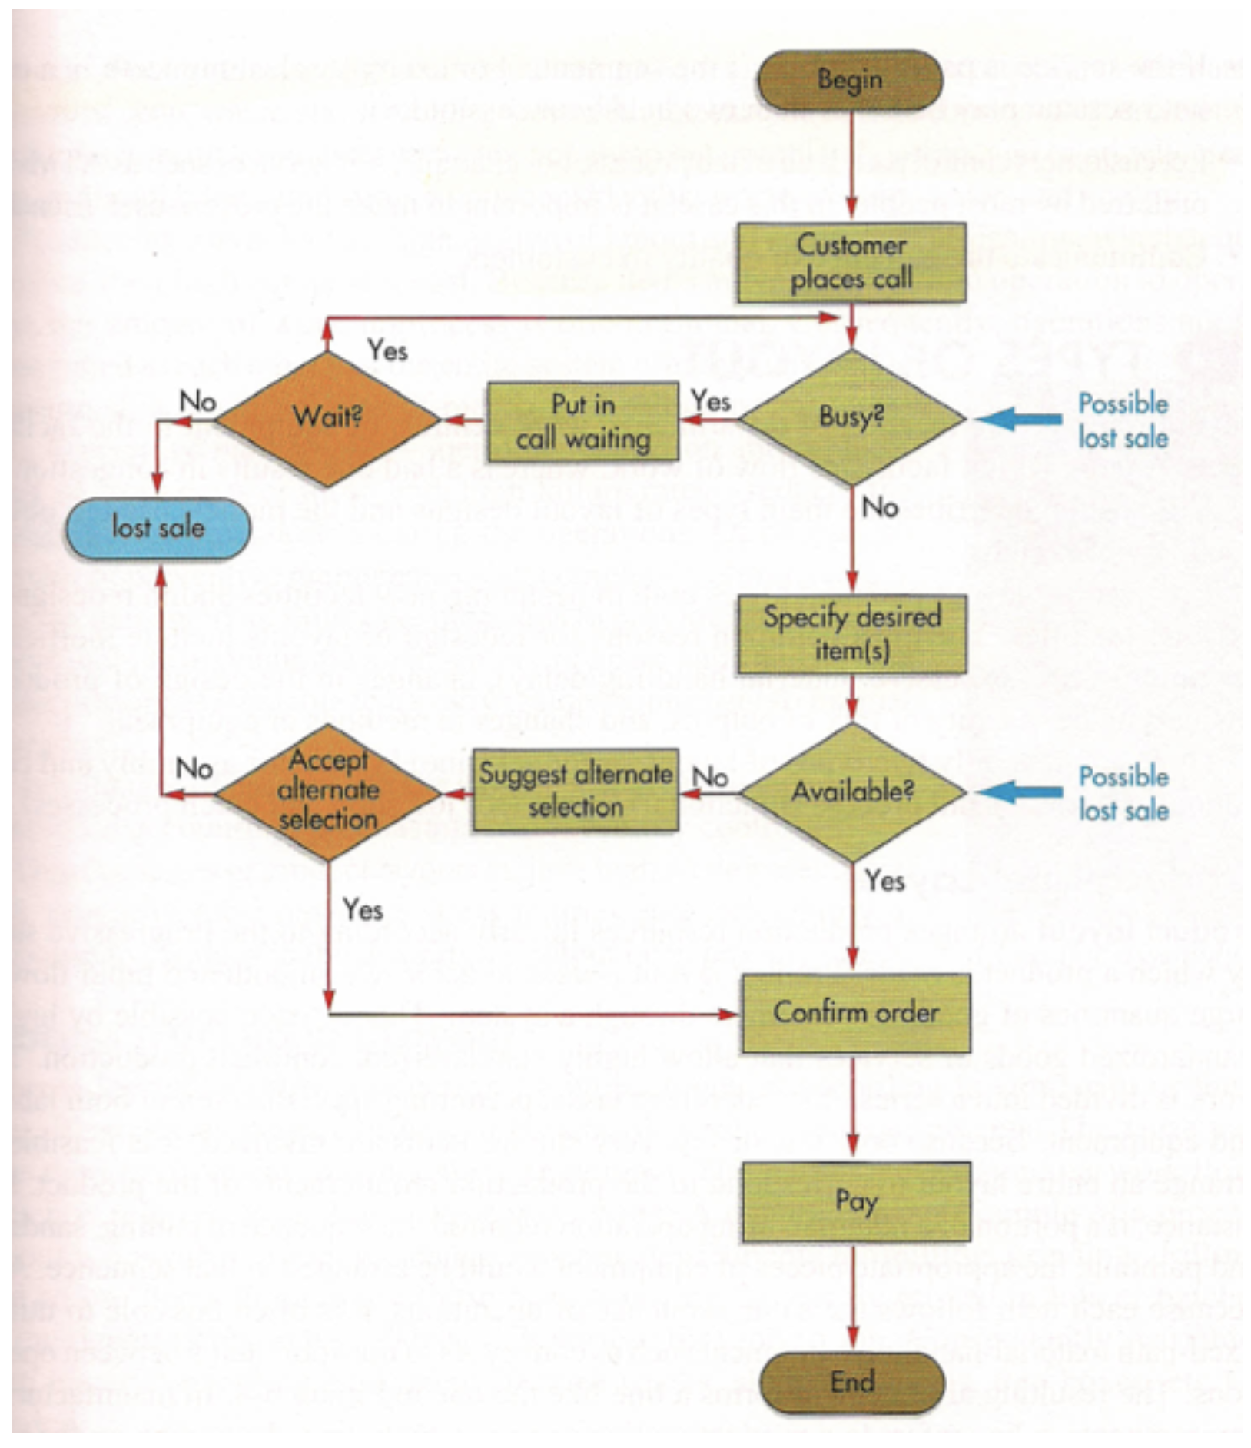

### Basic Layout Types

**Product (Line):** Arranges the process (plant layout) linearly according to the progressive steps by which a product is made.

**Process (Functional)**: Arranges production resources together according to the similarity of function.

**Cellular:** Layout in which different machines are arranged in a cell that can process items that have similar processing requirements.

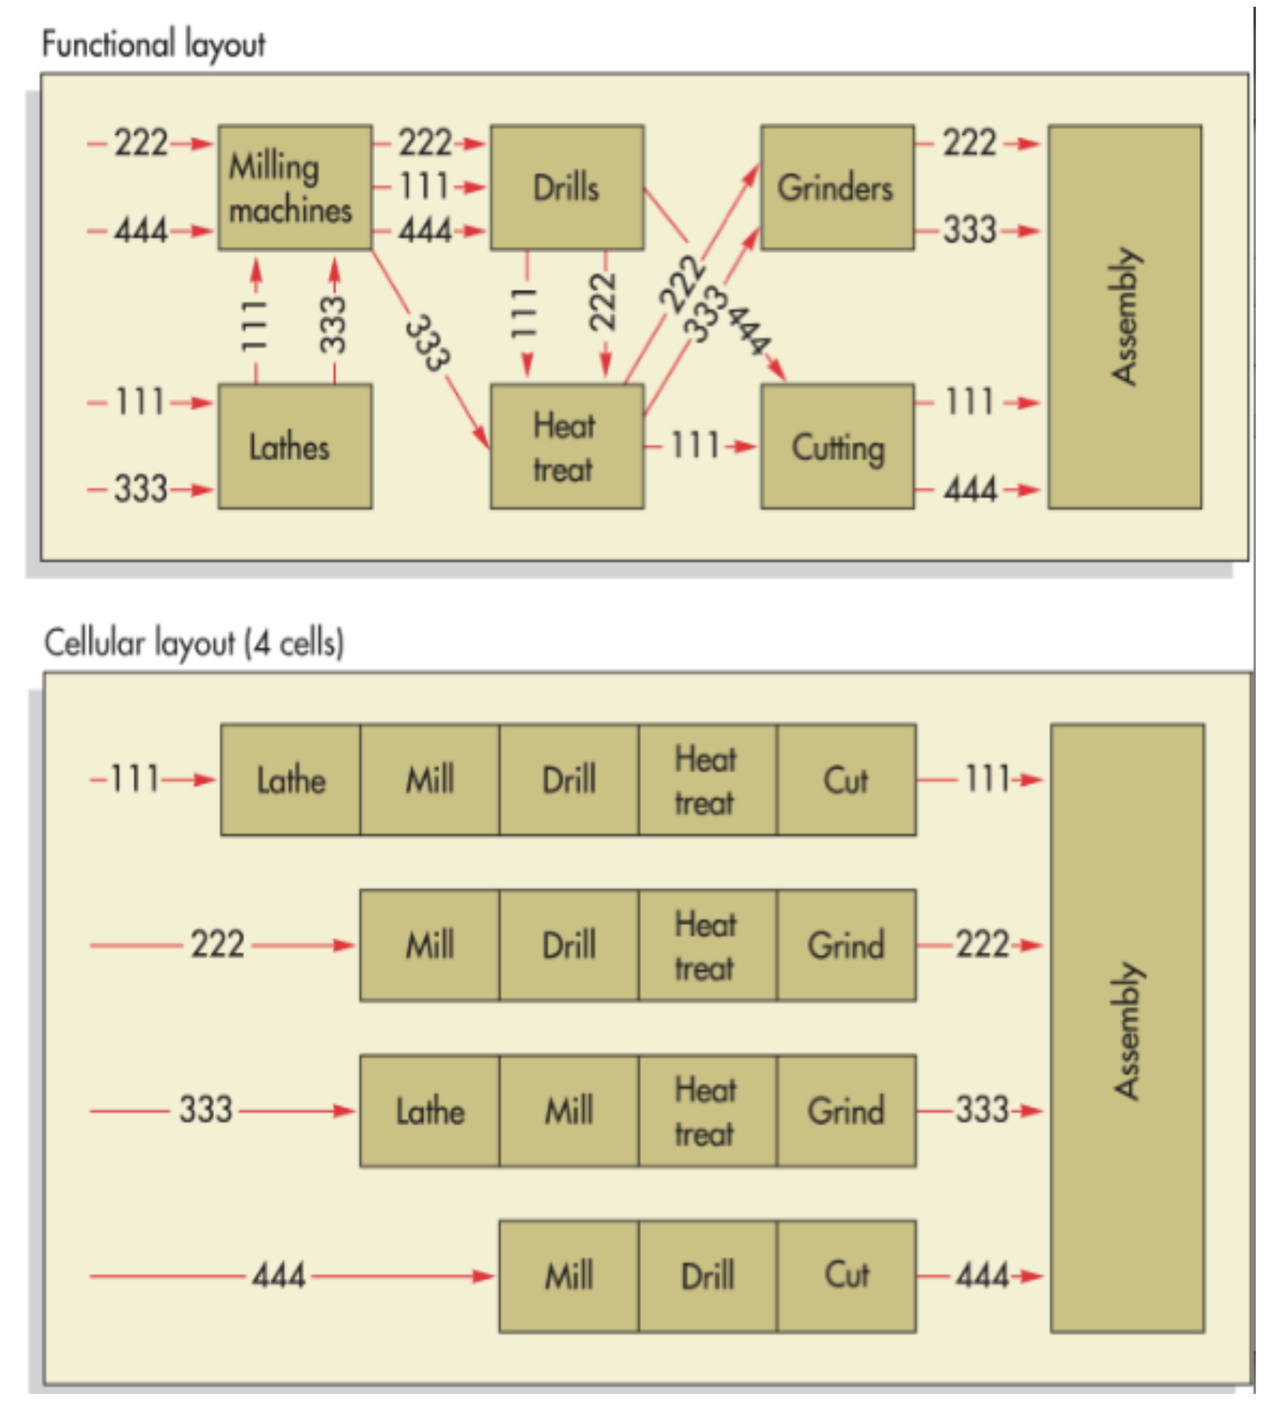

### Assembly Line Balancing

* + Assigning tasks to workstations such that the workstations have approximately equal time requirements
  + Cycle time is determined by the desired output rate:
 $$Cycle Time=\frac{Operating Time Per Day}{Desired Output Rate}$$

 + Number of workstations is determined by the cycle time, the sum of task times, and the ability to bundle activities into appropriately sized workstations:
 $$Theoretical Number of Workstations=\frac{Sum of Task Times}{Cycle Time}$$

 + **Precedence Network:** A diagram that shows the task and their precedence requirements
  + **Balancing Rules:** Assign the tasks with the longest time, assign the task with the most followers

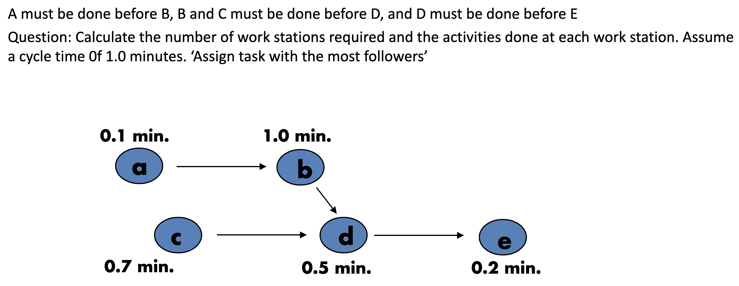

|  |  |  |  |  |  |
| --- | --- | --- | --- | --- | --- |
| **Workstation** | **Time Remaining** | **Eligible** | **Assign Task** | **Revised Time Remaining** | **Station Idle Time** |
| $$1$$ | $$1.0$$ $$0.9$$ $$0.2$$ | $$a, c$$ $$c$$ $$none$$ | $$a$$ $$c$$ $$-$$ | $$0.9$$ $$0.2$$ | $$0.2$$ |
| $$2$$ | $$1.0$$ | $$b$$ | $$b$$ | $$0.0$$ | $$0.0$$ |
| $$3$$ | $$1.0$$ $$0.5$$ $$0.3$$ | $$d$$ $$e$$ $$-$$ | $$d$$ $$e$$ $$-$$ | $$0.5$$ $$0.3$$ | $$0.3$$ $$0.5$$ |

Two measures of facility layout effectiveness:

$$Percentage Idle Time=\left\{\frac{Sum of Idle Times}{Actual Number of Workstations×Cycle Time}\right\}×100$$

$$Efficiency of the Line=100-Percentage Idle Time$$

In this example:

$$\% idle time=\frac{0.5}{3×1.0}×100=16.7\% \\ efficiency=100\%-16.7\%=83.3\%$$

**Dealing with Variable Task Times**

* + Task times vary due to worker fatigue, boredom, mechanical failures, shortages, etc.
  + Solutions: Reduce variability in the task time themselves, allow for use of buffer inventories, build some idle time into the process itself, cross training workers

**Resolving Bottlenecks**

* + The task time of the slowest workstation will determine the cycle time for the entire line
  + Solutions: Parallelize workstations to decrease process time in half, cross train workers

